The Impact of Economic Policy Uncertainty on Housing Market Returns in Korea

Ji-Hong Jeon*, Yeong-Suk Cho**

Abstract

In this paper, we examine the impact of economic policy uncertainty in the US and China on housing market returns including the spillover effect of stock prices and macroeconomic variables in Korea. We use the nine variables to analyze the effect which produces a result among the economic policy uncertainty index of the US and China on macroeconomic indicators such as the consumer price index, housing purchase price composite index, housing lease price, the stock price index in banking industry, construction industry and distribution industry, and composite leading indicator from January 1995 to December 2016 with the Vector Error Correction Model. The US economic policy uncertainty index has significantly a negative effect on the consumer price index, housing purchase price index, housing lease price index, the stock price index in banking industry, construction industry and distribution industry about the housing market in Korea. In this paper, we examined the relationship between the economic policy uncertainty index and the housing market in Korea. This study has an empirical evidence that the housing market in Korea is influenced by the economic policy uncertainty index of the US rather than it of China.

Keywords: Economy policy uncertainty, Housing Market, Stock market, Vector Error Correction Model.

JEL Classifications: C32, D80, E60, E66.

1. Introduction
Can economic policy uncertainty (EPU) of the world's great powers, the US and China, affect the Korean economy, especially the housing market? What country's EPU will have more impact if it affects Korea's housing market? The purpose of this study is to examine the impact of EPU of the US and China, which are the world 's greatest economies, on the Korean housing market. Today, the impact of the US and China on the world economy is huge. Especially, the effects of developed countries' economic crisis on the economic market of the developing countries in the past, such as the global financial crisis, were incomprehensible. For example, in the aftermath of the subprime mortgage crisis in the US in 2007, many Asian and European countries, including Korea, have adversely affected not only the national economy but also the housing market. We can find out through previous studies that the uncertainties in national economic policy and the relationship with the housing market are very close.
Alesina and Rodrik (1994) argue that as an inequality of wealth and income increase, the rate of taxation increases, and that economic growth slows down. The results show that inequality in land and income ownership has a negative correlation with the next economic growth. According to Baffoe-Bonnie (1998), housing prices and housing stock are directly related to US economic cycles. In this connection, the government says that the overall economy has been driven by the policies of the housing market. If financial policies are actively pursued, they can lead the economy steadily. Housing is an important factor in the economy. Pantzalis et al. (2000) study the response to the stock market during the political election period for 33 countries including the US and Korea. In the two weeks prior to the political election, there are positive and meaningful stock market reactions. As a result, it is the value of an asset increases as uncertainty increases and uncertainty resolves just before the election process. Meen (2002) finds that differences in the time-series of house prices for the United States and the UK are related to the policy concern and the institutional structure. Benjamin et al. (2004) analyze real estate and financial wealth, pensions and insurance, as an example of US consumption. Tax policy also focuses on debt and assets on housing, deducting mortgage rates and lowering interest rates at the national level to boost household consumption and increase debt. Leung (2004) highlight the importance of the housing market and the macroeconomy through more than 200 precedent studies and find that housing is important because it is a large part of the overall macroeconomy. In other words, housing is an important part of the total wealth along with household expenditure. Brunnermeier and Julliard (2008) use the US housing market to analyze the relationship between home prices and inflation. Also, using the price-rent ratio of the house price, the construction cost, the population change, and the change in the housing quality are found to be symmetrical with the housing and rental prices in the long term. Park (2011) analyze whether the introduction of comprehensive real estate holding tax can affect the price of real estate. According to the results of the study, apartment prices drop significantly after the introduction of comprehensive real estate holding tax, and the taxation and public policy of the government affect housing prices.
Canes-Wrone and Park (2012) study that the presidential candidate's policy in the US election would delay the purchase of home if there is a lot of gap between the survey participants' perception. In the end, changes in the US housing market affect the incentives of individuals seeking to buy a home. Specifically, when the state creates or expands tax-exempt areas for business, the tax-exempt areas would be more active in real estate. Antonakakis et al. (2013) study the relationship between US economic policy uncertainty and stocks. The increase in uncertainty volatility weakens the stock market, while the increase in volatility in the stock market increases uncertainty. In other words, the policy uncertainty and the stock market move steadily negative over time. Kang and Ratti (2013) also study that the increase in US uncertainty has a negative impact on stocks. The impact of oil prices has heightened economic policy uncertainty and adversely affects European stocks and energy exporters, Canada. Pástor and Veronesi (2013) develop a model of government policy choices for stock prices responding to political news. The risk premium causes by policy uncertainty is larger as the economy weakens. In other words, policy uncertainty is analyzed to make stocks more volatile and correlated, especially when the economy is weak.
Colombo (2013) studies the impact of US economic policy uncertainty impacts on macroeconomic variables such as consumer price index (CPI) and industrial production index (IPI) in Europe through structural VAR. US economic policy uncertainty has led to a significant decline in production and prices in the European industry. The impact of economic uncertainty in the United States has a greater impact on the macroeconomy than in the European counterpart. Karnizova and Li (2014) study EPU and financial markets during the US downturn. Using the Probit recession forecasting model, they find that economic policy uncertainty is useful in predicting the economic rate of interest rate spreads, stock prices, and stock market volatility over five quarters. Especially, newspaper-based indexes can be used as the best predictor. Bloom (2014) often uses volatility in the stock market and GDP as a means of uncertainty about US economic policy uncertainty, as the unpredictability of volatility is more pronounced and uncertainty becomes more pronounced. Especially in the recession, the volatility of the Standard & Poor's 500 stock market in the US is even higher. Mian and Sufi (2014) study that it is be larger in countries experiencing a massive decline in housing net worth as business uncertainty increases, while housing booms are likely to increase in pre-recession employment patterns, such as Great Recession. and the effect on the employment pattern. A study of the United States found that the greater the impact of uncertainty, the worse the economy could be. Liu and Zhang (2015) studied the predictability of US economic policy uncertainty and stock market volatility, and found that the higher the EPU, the more significant the market volatility increases. Muellbauer (2015) examines the US CPI associated with Rents, Rents are slowly increasing compared to home sales prices, but highly correlated. Home prices are an important predictor of US consumer prices one year ahead. Apergis (2015) discusses the role of politics in influencing US stock prices. After the economic downturn from 2007 to 2009, stocks are affected when economic instability such as taxes, government consumption, and monetary policy increases. In addition, unconventional monetary policy has found that it increases the instability of the currency shock and further lowers the share price.
Antonakakis et al. (2015) study stocks, housing, and economic variables due to economic fluctuations in the United States, focusing on economic policy uncertainties. Inflation, industrial production and the federal funds rate are used as economic variables. Housing and financial crises have had a ripple effect on the real economy and that a strong economic policy is needed to stabilize the economy. Baker et al. (2016) develop the economic policy uncertainty (EPU) index of more than 20 major countries including the US, Japan and Korea through the frequency of newspaper articles, and study the relationship between economic policy uncertainty and economic policy. Zheng et al. (2016) study that the housing market in China is an important aid to economic revitalization and the government's budget expansion, and that central and local governments are deeply involved in the housing market. It has also played a major role in the country's macroeconomic growth, consumption and investment. Ngene et al. (2017) study the conditions of the US housing market, uncertainties in financial markets, economic downturn and uncertainty in economic policy. The uncertainty of economic policy and the housing market are inversely related, and as the uncertainty increases, the housing market growth and investment are adversely affected. Li & Peng (2017) study the impact of US economic policy uncertainty on the US and Chinese stock markets. As a result, it has shown a negative impact on US economic policy uncertainty and the relationship between the US and Chinese stock markets. For example, when US policy uncertainty is very high or low, it has reduced the correlation between the US and Chinese stock markets.
There are many studies on economic policy uncertainty and housing for Korean scholars. Kim (2004) studies housing prices, consumer spending and inflation in Korea and explains the causal relationship between home prices and inflation. House prices are affecting the housing market and macroeconomic variables, and the sharp decline in interest rates and consumer credit growth are the factors that increase housing prices in Korea. The increase in housing prices is an important predictor of inflation because it affects workers' salary increases. CPI inflation is attributed to the purchase price of the house and the charter price index. Lee (2010) studies the impact of domestic and foreign news shocks on the volatility of domestic financial markets. As a result, foreign news shocks such as the US interest rate and exchange rate have more volatility in domestic financial variables than domestic news shocks. Yu and Lee (2010) investigate the housing policy and housing market instability developed by the government in the past when Roh, Nu Hyun administration is established. They use GDP, CPI, and money supply as macroeconomic variables that affect the destabilization of housing prices in Korea. As a result, corporate bond returns, money supply, and building construction permits are significant, but the government's housing policy changes several times to stabilize housing, but it has no effect on housing prices. It is said that excessive housing policy has adversely affected the consumers' sense of buying home. Jo (2011) studies the relationship between the deposit lease price and the housing price in Korea and finds that the uncertainty of expected housing yield affects the rent price. And that the demand for rental housing is directly proportional to the demand for housing. The rest of this study is as follows. Section 2 describes the data and models used in the empirical analysis, and Section 3 shows the empirical results. Section 4 outlines key findings and implications. Lee and Hwang (2016) explain the financial and economic fluctuations of China through the analysis of housing prices using 31 panel data of gender in China. For financial variables, gross regional domestic product volatility is selected as a variable for credit and home sales price is selected as a variable for assets. As a result, it is found that the magnitude of the credit and the volatility increase the fluctuation of the economy, but the effect of the rise in the home sale price and the volatility on the economic fluctuation was uncertain. This shows that the expansion of financial volatility in China can deepen the economic fluctuations and increase the uncertainty of the economy. There are also studies on credit channels and housing markets for financial policies.
2. Data and methodology
2.1. Data
We use monthly data from January 1995 to December 2016 for this study. The nine variables use in this study are macroeconomic variables that show the impact of the economic policy uncertainty of the US and China on the Korean housing market. The CPI, housing purchase price index (HPPI), housing lease price index (HLPI), construction stock index (CSI), and banking stock index (BSI), distribution stock index (DSI) and composite leading indicator (CLI). The data sources are EPUs from the United States and China that come from Baker et al. (2016). As a macroeconomic index, the CPI and CLI are data from the Statistics Korea (KOSTAT). The HPPI and HLPI are data from Kookmin Bank (KB), one of the largest banks in Korea. And the CSI, BSI, DSI are supplied by FnGuide.
Previous studies show that CPI is an index closely related to EPU. (Sung et al., 2014; Jeon et al., 2017). Fig. 1 illustrates the relationship between CPI, HPPI, and HLPI. Korea 's CPI has risen 89% over the last 22 years, with HPPI and HLPI rising 84% and 145%, respectively. Yu and Lee (2010), we can see that Korea's CPI is closely related to HPPI and HLPI. As for the CLI, Atabek et al. (2005) show that Turkey's leading economic index responded to economic changes in advance. In addition, CLI predict changes in economic growth and contraction through long-term trends.

Fig. 1. The cycle of the index of Consumer Price, Housing Purchase Price and Housing Lease Price, and Composite Leading Indicator. (1995:01-2016:12).

Fig. 2. The cycle of the Construction Stock Index, Banking Stock Index and Distribution Stock Index. (1995:01-2016:12).
As for the stock price index, Fig. 2 shows that CSI, BSI, and DSI move in the same direction. CSI, BSI, and DSI are the indexes for the housing market. When the housing market improves, the housing, financial, and retail stock indexes are also rising. On the other hand, as the economic policy uncertainty index rises, it can be predicted that the stock index will fall.

Table 1
Descriptive Statistics.
 | US EPUI | China  EPUI | CPI | HPPI | HLPI | BSI | CSI | DSI | CLI
Mean | 4.644 | 4.610 | 4.361 | 4.278 | 4.141 | 5.485 | 4.969 | 5.878 | 4.391
Median | 4.612 | 4.607 | 4.371 | 4.268 | 4.139 | 5.483 | 5.003 | 6.052 | 4.418
Min. | 3.801 | 2.204 | 3.981 | 3.905 | 3.624 | 4.288 | 3.644 | 4.729 | 3.879
Max. | 5.647 | 6.372 | 4.621 | 4.619 | 4.621 | 6.452 | 6.275 | 6.498 | 4.858
S.D. | 0.369 | 0.656 | 0.188 | 0.235 | 0.280 | 0.434 | 0.657 | 0.433 | 0.282
N | 264 | 264 | 264 | 264 | 264 | 264 | 264 | 264 | 264
Note: EPUI, CPI, HPPI, BSI, CSI, DSI, CLI indicate separately Economy Policy Uncertainty Index, Consumer Price Index, Housing Purchase Price Index, Housing Lease Price Index, Banking Stock Index, Construction Stock Index, Distribution Stock Index, Composite Leading Indicator

2.2. Methodology
In this study, Vector Error Correction Model (VECM) is used instead of Vector Auto Regression (VAR) by using the relationship between cointegration and error correction model proposed by Granger (1981). The reason is that if there is no unit root in the first difference variable but we find the cointegration relation through the cointegration test, we can prevent the information loss that can occur in the first difference using VECM.
$∆Y_{t}= \sum_{i=1}^{s-1}{Θ_{i}}∆Y_{t-i}+αβ^{'}Y_{t-s}+$Ω+$ϵ_{t}$ (1)
where $Y_{t}$ is a vector of $(p×1$) matrix when the endogenous variables are I (1), that is, p is Economy Policy Uncertainty Index in the US and China, Consumer Price Index, Housing Purchase Price Index, Housing Lease Price Index, Construction Stock Index, Banking Stock Index, Distribution Stock Index, and Composite Leading Indicator); i is lag order (1, 2, …, N); $s is$ maximum of lag order; $t$: period (1, 2, …, T); $Θ_{i}$ is $p×p$matrix coefficient; $αβ^{'}Y_{t-s}$: lagged error correction term, where $α$ is adjustment parameters, and $β^{'}$ is cointegration vectors; $Ω$ is vector of deterministic components; $ϵ_{t}$ is $(p×1$) vector of disturbances.

3. Empirical findings
3.1. Unit Root Test
A Unit root test is conducted to determine if there is strong autocorrelation between monthly time series by Granger and Newbold (1974). The results of the Augmented dickey fuller (ADF) and Phillips-Perron (PP) tests are shown in Table 2. The level variable that take log data in raw data has a unit root, but there is no unit root in the first difference result. Therefore, it can be said that the first subordinate time series has stability because there is no unit root.

Table 2
Unit Root Tests.
 |  | ADF Test |  | PP Test
 |  | Level | 1st Difference | Level | 1st Difference
US  EPUI | Con. | -4.468 | -13.968*** | -5.900 | -21.706***
US  EPUI | Con. & Trend | -5.052 | -13.942*** | -6.625 | -21.661***
China EPUI | Con. | -3.474 | -15.300*** | -7.994 | -31.580***
China EPUI | Con. & Trend | -4.914 | -15.321*** | -10.006 | -31.723***
CPI | Con. | -3.132 | -11.001*** | -3.344 | -10.699***
CPI | Con. & Trend | -1.500 | -11.732*** | -1.435 | -10.995***
HPPI | Con. | -0.077 | -5.838*** | 0.068 | -5.115***
HPPI | Con. & Trend | -2.037 | -5.845*** | -1.926 | -5.116***
HLPI | Con. | -0.078 | -5.787*** | -0.115 | -5.005***
HLPI | Con. & Trend | -1.856 | -5.782*** | -1.971 | -4.994***
BSI | Con. | -2.763* | -8.278*** | -2.818* | -15.237***
BSI | Con. & Trend | -2.732 | -8.323*** | -2.788 | -15.262***
CSI | Con. | -2.262 | -8.270*** | -2.348 | -14.725***
CSI | Con. & Trend | -2.235 | -8.314*** | -2.322 | -14.744***
DSI | Con. | -2.390 | -9.678*** | -2.413 | -14.366***
DSI | Con. & Trend | -3.172* | -9.721*** | -3.178* | -14.379***
CLI | Con. | -0.581 | -7.762*** | -0.809 | -6.468***
CLI | Con. & Trend | -3.256* | -7.755*** | -2.457 | -6.455***
Note:
1. EPUI, CPI, HPPI, BSI, CSI, DSI, CLI indicate separately Economy Policy Uncertainty Index, Consumer Price Index, Housing Purchase Price Index, Housing Lease Price Index, Banking Stock Index, Construction Stock Index, Distribution Stock Index, Composite Leading Indicator
2. ADF and PP denote Augmented Dickey-Fuller and Phillips-Perron respectively.
3. Con, Con. & Trend denote constant, and constant and trend separately.
4. ***, **, * mean 1%, 5%, 10% levels.

3.2. Cointegration Test
We conclude that the cointegration relation of time series exists through the cointegration test developed by Johansen (1988) as shown in Table 3. Johansen test is divided into Trace statistic and Maximum eigen value (λmax). Ho is a hypothesis that there is no cointegration. Because the cointegration exists, the VECM, rather than the VAR, is used for the empirical analysis.

Table 3
Cointegration Test.
Ho | Trace | 5% Critical Value | λmax | 5% Critical Value
r=0 | 304.52 | 192.89 | 100.86 | 57.12
r≤1 | 203.66 | 156.00 | 55.20 | 51.42
r≤2 | 148.46 | 124.24 | 40.99 | 45.28
r≤3 | 107.47 | 94.15 | 33.45 | 39.37
r≤4 | 74.02 | 68.52 | 26.68 | 33.46
r≤5 | 47.34 | 47.21 | 21.78 | 27.07
r≤6 | 25.56* | 29.68 | 14.76 | 20.97
Note: * means p<0.05.
3.3. Granger Causality Test
We conducted the Granger causality test by Granger (1980) to examine the impact of US and Chinese EPU on the Korean economy. In Table 4, , if the null hypothesis (Ho) is significant between the EPU index of two countries and Korean economic index variables, it will be rejected, and the alternative hypothesis will be adopted. The US EPUI had a causal relationship to all Korean economic index variables except CLI. China EPUI had a causal relationship to all Korean economic index variables. The Granger causality test showed that the EPUI of the US and China had a significant causal relationship to the Korean economy.

Table 4
Granger Causality Tests.
 | Ho | F-Statistic
CPI & US EPUI | CPI ⇏ US EPUI | 3.706**
CPI & US EPUI | US EPUI ⇏ CPI | 3.705**
HPPI & US EPUI | HPPI ⇏ US EPUI | 0.097
HPPI & US EPUI | US EPUI ⇏ HPPI | 4.185**
HLPI & US EPUI | HLPI ⇏ US EPUI | 2.890*
HLPI & US EPUI | US EPUI ⇏ HLPI | 11.159***
BSI & US EPUI | BSI ⇏ US EPUI | 8.269***
BSI & US EPUI | US EPUI ⇏ BSI | 4.284**
CSI & US EPUI | CSI ⇏ US EPUI | 1.313
CSI & US EPUI | US EPUI ⇏ CSI | 9.936***
DSI & US EPUI | DSI ⇏ US EPUI | 0.893
DSI & US EPUI | US EPUI ⇏ DSI | 11.456***
CLI & US EPUI | CLI ⇏ US EPUI | 5.031**
CLI & US EPUI | US EPUI ⇏ CLI | 0.007
CPI & China EPUI | CPI ⇏ China EPUI | 0.404
CPI & China EPUI | China EPUI ⇏ CPI | 6.309**
HPPI & China EPUI | HPPI ⇏ China EPUI | 0.069
HPPI & China EPUI | China EPUI ⇏ HPPI | 5.821**
HLPI & US EPUI | HLPI ⇏ China EPUI | 0.229
HLPI & US EPUI | China EPUI ⇏ HLPI | 10.650**
BSI & China EPUI | BSI ⇏ China EPUI | 5.873**
BSI & China EPUI | China EPUI ⇏ BSI | 2.981*
CSI & China EPUI | CSI ⇏ China EPUI | 0.225
CSI & China EPUI | China EPUI ⇏ CSI | 9.344**
DSI & China EPUI | DSI ⇏ China EPUI | 1.416
DSI & China EPUI | China EPUI ⇏ DSI | 4.865*
CLI & China EPUI | CLI ⇏ China EPUI | 13.771***
CLI & China EPUI | China EPUI ⇏ CLI | 2.916*
Notes:
1. ⇏ means “does not Granger Cause”.
2. ***, **, * mean 1%, 5%, and 10% levels.
3. EPUI, CPI, HPPI, BSI, CSI, DSI, CLI indicate separately Economy Policy Uncertainty Index, Consumer Price Index, Housing Purchase Price Index, Housing Lease Price Index, Banking Stock Index, Construction Stock Index, Distribution Stock Index, Composite Leading Indicator

3.4. VECM
Optimal lags for VECM are set to lag 2 through the Schwarz-Bayesian Information Criterion (SBIC) as shown in Table 5.

Table 5
Estimation Results of VECM.
lag | SBIC |  | HQIC | AIC
0 | -8.880 |  | -8.954 | -9.003
1 | -35.060 |  | -35.797 | -36.293
2 | -36.125* |  | -37.526 | -38.467
3 | -35.604 |  | -37.668 | -39.055
4 | -34.610 |  | -37.337 | -39.171
Note:
1. * means the optimal lag order.
2. SBIC, AIC, HQIC denote respectively Schwarz-Bayesian Information Criterion, Hannan-Quinn Information Criterion, Akaike Information Criterion.

The results for VECM are shown in Table 6. The US EPUI has a significant negative relationship to all Korean economic indices except CLI. On the other hand, in China EPUI, only the CLI of all Korean economic indices has a significant negative relationship.

Table 6
Estimation Results of VECM.
 | US EPUI | China EPUI
CPI | -0.002** (0.001) | -0.001 (0.001)
HPPI | -0.002** (0.001) | 0.001 (0.001)
HLPI | -0.003** (0.001) | 0.001 (0.001)
BSI | -0.052* (0.029) | 0.014 (0.014)
CSI | -0.065** (0.032) | 0.0148 (0.016)
DSI | -0.072*** (0.026) | -0.003 (0.013)
CLI | -0.001 (0.001) | -0.001** (0.001)
Notes:
1. ***, **, * mean 1%, 5%, and 10% levels.
2. ( ) means standard errors.

3.5. Impulse responses
Impulse Response Functions to Economic Policy Uncertainty Index Shocks of the US and the China are shown in Fig. 3.
US EPUI (Impulse) | China EPUI (Impulse)
US EPUI ⇒ CPI  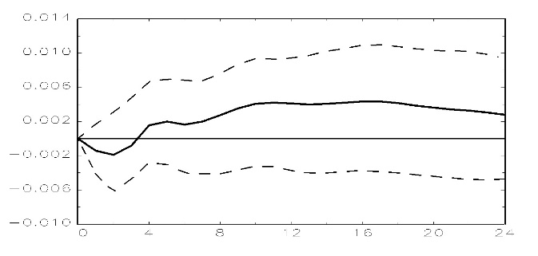 | China EPUI ⇒ CPI  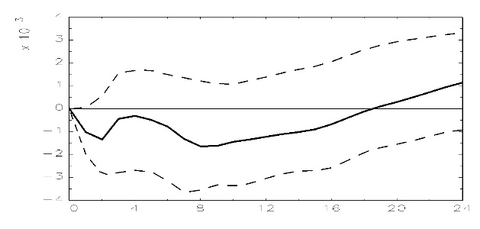
US EPUI ⇒ HPPI  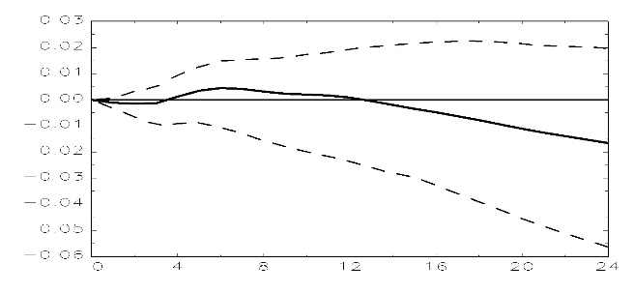 | China EPUI ⇒ HPPI  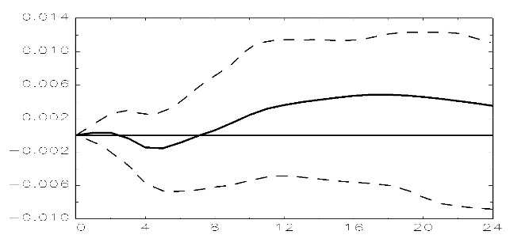
US EPUI ⇒ HLPI  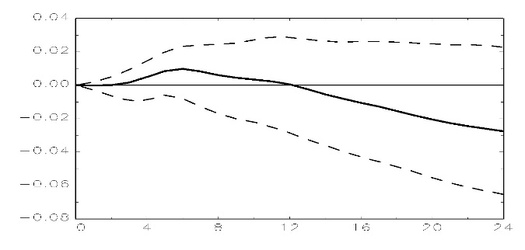 | China EPUI ⇒ HLPI  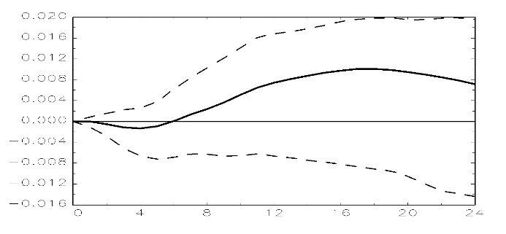
US EPUI ⇒ BSI  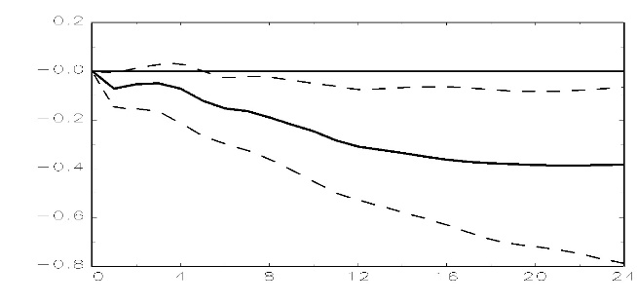 | China EPUI ⇒ BSI  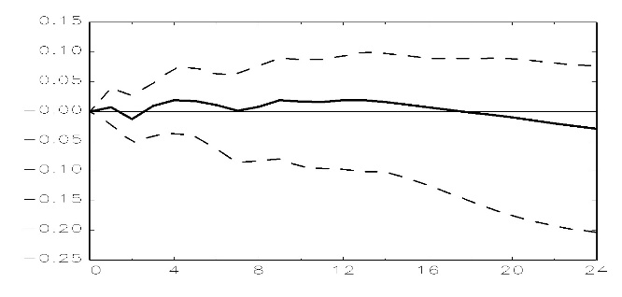
US EPUI ⇒ CSI  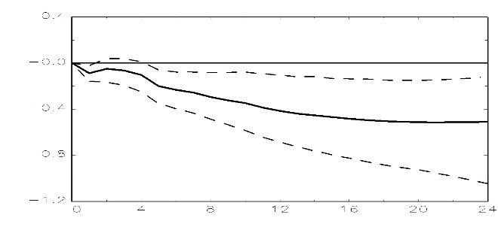 | China EPUI ⇒ CSI  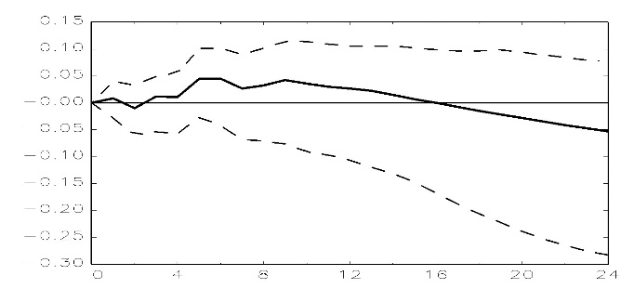
US EPUI ⇒ DSI  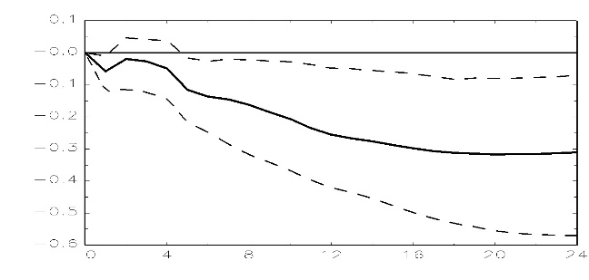 | China EPUI ⇒ DSI  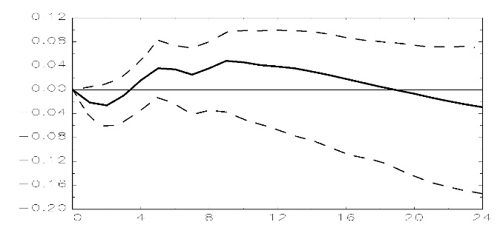
US EPUI ⇒ CLI  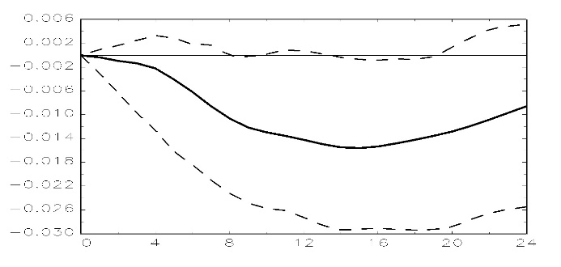 | China EPUI ⇒ CLI  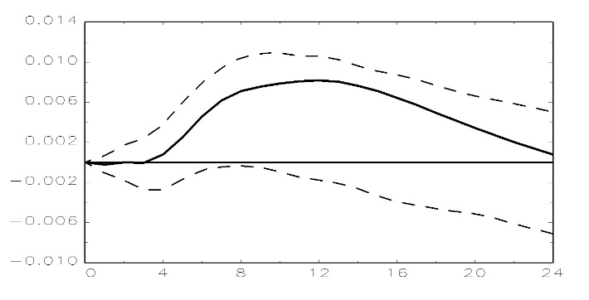
Note: The thick line means the impulse response. And the dotted line means 95% confidential nterval.
Fig. 3. Impulse Response Functions to Economic Policy Uncertainty Index Shocks of the US and the China.

3.5.1. Impulse response of EPU index in US
In detail, the CPI suddenly drops after impact on the US EPUI, reaching the lowest point in the second period. The decline in US EPUI stimulates CPI's demand. The reaction from the 2nd stage reaches the peak in the 10th stage. Bloom (2009) analyzed the CPI as an impact response function. As a result, US EPU shock indicates that the consumer price declines to 5% due to the rapid economic downturn, economic instability, and decreased consumer demand. The HPPI declined after the impact of US EPUI, but it went up to the 4th phase, shifted to the positive, climbed to the peak of 6th, then dropped again, and turned negative to 12th. The HLPI also moves to the same type of trend as HPPI. The BSI began to decline to negative from the beginning of the US EPU shock and continued to decline over time. CSI and DSI have a trend like BSI. The CLI began to decline to negative from the beginning to the US EPU shock and was raised to the lowest point in the 14th period.

3.5.2. Impulse response of EPU index in China
In detail, the CPI suddenly drops to 2 after the shock to the China EPUI and rises to 4 again. And then down again to reach the lowest point by 8th. The HPPI rose in the early stage after the impact of the China EPUI, then fell to the negative as it entered the third period, reached the lowest point in the fifth period, and then rose again. HLPI also moves to the same type of trend as HPPI. BSI and CSI rose in volume at the beginning, reached the lowest point in the second period, and then repeatedly rising and falling, eventually dropping to negative. The DSI declined in the early period, then rose from the second period, changed into positive period in the fourth period, and repeatedly ascending and descending, but eventually declined to negative level in the 19th period. The CLI initially fell to negative, then switched to positive at 4th, and then dropped to its peak at 12th.

3.6 Comparison of Impulse response of EPU index in Korea and the US
In order to analyze the effects of the shocks proposed by Sims (1980), we can see that the US EPUI proceeds in negative direction for all economic variables in Korea initially through the impact response coefficient. On the other hand, China EPUI is initially positive in the direction of HPPI, BSI, and CSI, and CPI, HLPI, DSI and CLI are initially positive.

4. Conclusions
4.1. Summary of results
In this study, we examined the effect of economic policy uncertainty in the US and China on the housing market in Korea with monthly data from January 1995 to December 2016. Particularly, EPU is due to economic policy uncertainty index, and Korea's housing economy is trying to find out through HPPI, HLPI which can see housing price, and construction, distribution, and banking industry related to housing price.
Empirical analysis showed that the Granger causality test showed that the EPUI of the US and China had a significant causal relationship to the Korean economy. Particularly, the US economic policy uncertainty index had a causal relationship to all Korean economic index variables except CLI. China EPUI had a causal relationship to all Korean economic index variables. The Granger causality test showed that the EPUI of the US and China had a significant causal relationship to the Korean economy. Also, through the VECM, the US EPUI has a significant negative relationship to all Korean economic indices except CLI. On the other hand, in China EPUI, only the CLI of all Korean economic indices has a significant negative relationship. We also used impact response coefficients to analyze the impact of the shocks proposed by Sims (1980) through EPU in the US and China. The US EPUI is initially negative for all economic variables in Korea. On the other hand, China EPUI is initially positive in the direction of HPPI, BSI, and CSI, and CPI, HLPI, DSI and CLI are initially positive.

4.2. Implications
Through this study, we examined the effect of economic policy uncertainty in the US and China on the Korean economy. First, the Korean housing market is more affected by the US than China. One reason is related to the economic policy uncertainty of the US government. For example, in 2003, "the US war in Iraq and the global financial crisis in 2008-2009 caused the Korean housing market to deteriorate. I believe that the economic policy uncertainty of the world is reflected in the housing market of the country. This study differs from the existing research as follows.
First, this study shows whether the economic policy uncertainty index of the US and China has the relationships on the housing market economy in Korea through the empirical analysis. Second, this study has an empirical evidence that the housing market in Korea is influenced by the economic policy uncertainty index of the US rather than it of China.

References

Atabek, A., Cosar, E. E., & Sahinöz. (2005). A new composite leading indicator for Turkish economic activity. Emerging Markets Finance & Trade. 41(1), 45-64.
Alesina, A., & Rodrik, D. (1994). Distributive politics and economic growth. Quarterly Journal of Economics, 109(2), 465-490.
Antonakakis, N., Chatziantoniou, I., & Filis, G. (2013). Dynamic co-movements of stock market returns, implied volatility and policy uncertainty. Economics Letters, 120(1), 87–92.
Antonakakis, N., Gupta, R., & Andre, C. (2015). Dynamic co-movements between economic policy uncertainty and housing market returns. Journal of Real Estate Portfolio Management, 21(1), 53-60.
Apergis, N. (2015). Policy risks, technological risks and stock returns: new evidence from the US stock market. Economic Modelling, 51, 359-365.
Baffoe-Bonnie, J. (1998). The Dynamic impact of macroeconomic aggregates on housing prices and stock of houses: a national and regional analysis. Journal of Real Estate Finance and Economics, 17(2), 179-197.
Baker, S. R., Bloom, N., & Davis, S. J. (2016). Measuring economic policy uncertainty, Quarterly Journal of Economics, 131(4), 1593-1636.
Benjamin, J., Chinloy, P., & Jud, G.D. (2004). Real estate versus financial wealth in consumption. Journal of Real Estate Finance and Economics, 29(3), 341–354.
Bloom, N. (2009). The impact of uncertainty shocks. Econometrica, 77(3), 623-685.
Bloom, N. (2014). Fluctuations in uncertainty. Journal of Economic Perspectives, 28(2), 153-176.
Brunnermeier, A. K. & Julliard, C. (2008). Money illusion and housing frenzies. Review of Financial Studies, 21(1), 135-180.
Canes-Wrone, B., & Park, J. K. (2012). Elections, uncertainty and irreversible investment. British Journal of Political Science, 44(1), 83-106.
Colombo, V. (2013). Economic policy uncertainty in the US: does it matter for the Euro area?. Economics Letters, 121(1), 39-42.
Granger, C. W. J. (1980). Testing for causality: A personal viewpoint. Journal of Economic Dynamics and Control, 2(4), 329-352.
Granger, C. W. J. (1981). Some properties of time series data and their use in econometric model specification. Journal of Econometrics, 16(1), 121-130.
Granger, C. W. J., & Newbold, P. (1974). Spurious regression in econometrics. Journal of Econometrics, 2(1), 111-120.
Jeon, J., Lee, H., & Lee, C. (2017). Economic policy uncertainty and Korean economy: focusing on distribution industry stock market. Journal of Distribution Science, 15(12), 41-51.
Johansen, S. (1988). Statistical analysis of cointegration vectors. Journal of Economic Dynamics and Control, 12, 231–254.
Kang, W., & Ratti, R. A. (2013). Oil shocks, policy uncertainty and stock market return. Journal of International Financial Markets, Institutions & Money, 26, 305-318.
Karnizova, L., & Li, J. (2014). Economic policy uncertainty, financial markets and probability of US recessions. Economics Letters, 125(2), 261-265.
Kim, K. (2004). Housing and the Korean economy. Journal of Housing Economics, 13(4), 321–341.
Lee, K. (2010). The impact of international financial shocks on the volatility of domestic financial markets. Journal of Money & Finance, 24(4), 49-85.
Lee, J. & Hwang, J. (2016). Financial and business cycles in China: evidence from 31 provincial panel data. Journal of Modern China Studies, 18(3), 1-33.
Leung, C. (2004). Macroeconomics and housing: a review of the literature. Journal of Housing Economics, 13(4), 249-267.
Li, X. M., & Peng, L. (2017). US economic policy uncertainty and co-movements between Chinese and US stock markets. Economic Modelling, 61, 27-39.
Liu, L., & Zhang, T. (2015). Economic policy uncertainty and stock market volatility. Finance Research Letters, 15, 99-105.
Meen, G. (2002). The time-series behavior of house prices: a transatlantic divide?. Journal of Housing Economics, 11(1), 1-23.
Mian, A., & Sufi, A. (2014). What explains the 2007–2009 drop in employment?. Econometrica, 82(6), 3197-2223.
Muellbauer, J. (2015). Housing and the macroeconomy: inflation and the financial accelerator. Journal of Money, Credit and Banking, 47(1), 51-58.
Ngene, G. M., Sohn, D. P., & Hassan, M. K. (2017). Time-varying and spatial herding behavior in the US housing market: evidence from direct housing prices. Journal of Real Estate Finance and Economics, 54(4), 482-514.
Park, S. (2011). Housing market responses to the reinforcement of real estate tax. Korean Journal of Taxation Research, 28(1), 407-436.
Pástor, L., & Veronesi, P. (2013). Political uncertainty and risk premia. Journal of Financial Economics, 110(3), 520-545.
Pantzalis, C., Stangeland. D. A., & Turtle, H. J. (2000). Political elections and the resolution of uncertainty: the international evidence. Journal of Banking and Finance, 24(10), 1575-1604.
Sims, C. (1980). Macroeconomics and reality, Econometrica, 48(1), 1-48.
Sung, Y. A., Choe, H., & Kim, S. Y. (2014). Changes in consumption expenditure pattern during 1990-2010: a look through CPI. Journal of Consumption Culture, 17(4), 223-252.
Yu, H., Lee, S. (2010). Government housing policies and housing market instability in Korea. Habitat International, 34(2), 145-153.
Zheng, S., Sun, W., & Kahn, M. E. (2016). Investor confidence as a determinant of China’s urban housing market dynamics. Real Estate Economics, 44(4), 814-845.

* First Author, Adjunct Professor, School of Business, Hanyang University Tel: +82-2-2220-2435, E-mail: cellc@hanyang.ac.kr
** Corresponding Author, Professor, College of Business Administration, Mokpo National University Tel: +82-61-450-2631, E-mail: yscho@mokpo.ac.kr

