Stock and bond relationship in crisis periods in an emerging market: Local risk versus global risk

Keehwan Park*, Zhongzheng Fang** and Ha Young Ho**
November 2018

Abstract

This paper studies stock and bond relationship in crisis periods in an emerging market economy, using the case of the Korean economy. It is shown that the sign of stock and bond returns correlation depended on the origin of risk triggering the crisis. In the local risk- driven crisis, the “flight to quality” occurred across countries, causing the stock and bond prices to fall together. However, in the global risk-driven crisis, the “flight to quality” occurred across assets domestically, causing the stock price to fall, but the bond price to rise. It is also shown that the stock and bond returns correlation was systematically related to the changes in some macroeconomic variables, including business leading indicator.

Keywords: dynamic conditional correlation, flight to quality effect, local risk-driven crisis, global risk-driven crisis, stock market uncertainty, country risk.
JEL classification: G10, E44

Stock and bond relationship in crisis periods in an emerging market: Local risk versus global risk

1. Introduction

In the past, stock price and bond price tended to move in the same direction, but occasionally moved in the opposite direction for a prolonged period of time. Stock and bond returns correlation indeed varied over time. Particularly, the correlation behaved in a distinctive manner in crisis periods relative to in non-crisis periods.
A large literature documented this empirical phenomenon that the stock and bond returns correlation changed its sign in the past history. For example, the recent study by PIMCO (2013) showed that the correlation between the S&P 500 and long-term Treasuries has changed sign 29 times from 1927 to 2012, ranging from -93% to +86%. Li (2004) also documented that the major trends in stock and bond correlation for G7 countries followed a similar reverting pattern in the past forty years. Although there are a large literature on this subject, they are all for advanced economies, and not for emerging markets. An exception is Johansson (2010 a and 2010 b), which studied stock and bond relationship in Asian emerging markets during the 1997-1999 Asian financial crisis. Our paper fills this gap in emerging markets.
Our paper addresses three issues:
(1) How does stock and bond returns correlation behave in crisis periods as opposed to in non-crisis periods in an emerging market? And why?
(2) Does the sign of the correlation depend on whether the emerging market crisis is originated from local risk or global risk?
(3) Is the stock and bond returns correlation, if any, systematically related to the changes in some macroeconomic variables in an emerging market?
Stock and bond returns correlation is an important consideration when you have stock and bond in your investment portfolio. Your portfolio risk will depend much on the time-varying stock and bond returns correlation. When the economy is in a good (bad) time so that people have more (less) extra income to buy assets, we expect that both stock and bond prices may rise (fall) together. Likewise, when credit expands (contracts) in the economy so that people have more (less) money to buy assets, we expect that both stock and bond prices may rise (fall) together. In such cases, stock and bond are considered to be complements or in some way to be normal goods, and we expect that stock and bond return would be positively correlated.
However, in crisis periods, stock becomes a much riskier asset while government bond remains relatively a safer asset. Investors will substitute bond for stock. Stock price will fall while bond price rise as a result of the “flight to quality” effect. In such a event, we expect that stock and bond returns would be negatively correlated.
In the literature, there are two approaches to the study of stock and bond relationship. Shiller and Beltratti (1992), and Campbell and Ammer (1993) priced stock and bond by discounting their future cash flows, respectively, and using the pricing formulae, derived the stock and bond relationship. In this present value approach, the stock and bond discount rates are the crucial factors determining the stock and bond relationship. Among other factors, for example, inflation increases the discount rates for both stock and bond, and cetris paribus, decreases stock and bond prices together. This is particularly so when inflation is high, and the stock and bond returns correlation is hence predicted to be positive. These earlier present value models, however, implicitly assumed that the stock and bond returns correlation was constant.
In recent years, several researchers including Gulko (2002), Connolly et al. (2004), Andersson et al. (2008), and Baur and Lucey (2009) studied the time variation in the correlation, specially in periods with a negative correlation. They found that stock and bond returns were negatively correlated in periods of highly volatile stock market. They attributed this negative correlation in periods of elevated stock market uncertainty to the “flight to quality” phenomenon.
Connolly et al. (2004) studied the U.S. markets from 1986 to 2000, covering the 1987 black monday crash and the 1997 Asian financial crisis. Andersson et al. (2008) examined the financial markets in the U.S., U.K., and Germany from 1992 to 2006, covering the 1997 Asian financial crisis and the early 2000s dot. com. bubble. In these advanced markets, the negative correlation of stock and bond returns was observed in periods of crises. Indeed, capital was not really outflowed from these advanced countries in crisis periods, although bond was substituted for stock domestically as a result of the “flight to quality” phenomenon.
On the other hand, Johansson (2010 b) studied the emerging market economies from 1993 to 2008, and found that stock and bond returns correlation increased during periods of turmoil such as the 1997 Asian financial crisis in 9 Asian countries. In its conclusion, it was stated that if there was a flight to quality effect, it seemed to be in the form of capital moving away from a certain country rather than into a relatively safer asset in the same country. Noting that this “flight to quality” phenomenon in crisis periods has different implications for the stock and bond returns correlation between in advanced and emerging market economies, Johansson (2010 b) suggested that the stage of economic development might affect how stock return would be related to bond return in crisis periods.
Will this “flight to quality” effect on the stock and bond returns correlation in crisis periods qualitatively differ in emerging market economies from that in advanced economies? To put it in a specific way, will the stock and bond returns correlation be, in crisis periods, negative for advanced economies, but positive for emerging market economies? If it is not so, does it matter for the sign of the correlation whether the emerging market crisis is originated from local risk or global risk? To answer this question, we study the Korean economy, an emerging economy which experienced the crises originated from the local risk of the 1997-1999 Asian financial crisis and the global risk of the 2007-2009 global financial crisis and the 2010-12 European fiscal crisis.
Speaking of the methodology for estimating the time-varying correlation, a wide range of multivariate GARCH models have been proposed in the literature and used to estimate the time-varying covariance matrices. These have been surveyed by several authors including Bauwens et al. (2006), and Silvennoinen and Terasvirta (2009). However, these models involve estimation of numerous parameters and are more complex to deal with. In order to estimate the time-varying stock and bond returns correlation in the Korean economy, we will use two methods in our paper: Rolling window correlation (RWC) and dynamic conditional correlation (DCC) developed by Engle (2002, 2009). These two methods are quite simple, more intuitive, widely used in the industry, and also applied in numerous papers (e.g., Engle and Colacito, 2006, and Andersson et al., 2008).

Our paper contributes to the literature in an important way. We find in this study that:
(1) As a result of the “flight to quality” effect, the stock and bond returns correlation behaves in a distinctive manner in crisis periods as opposed to in non-crisis periods in an emerging market.
(2) The sign of the correlation depends on whether the emerging market crisis is originated from local risk or global risk. When the crisis is originated from local risk in the emerging market, capital is outflowed from the country due to the country risk, and the stock and bond prices fall together (i.e., the correlation becomes positive). When the crisis is originated from global risk, bond is substituted for stock locally, and the correlation becomes (more) negative.
(3) The stock and bond returns correlation is related to changes in some macro economic variables. We find that the stock and bond returns correlation is positively related to business leading indicator, albeit at a marginal significance level. When business leading indicator increases, stock is substituted for bond, which is exactly the opposite of the “ flight to quality” effect.
The paper is written as follows: Section 2 describes and shows our time-series data in Figures. In Section 3, we estimate the time-varying correlation of stock and bond returns using both the rolling window model and the Engle’s DCC model (2002, 2009) . Section 4 discusses local risk and global risk of the Korean economy`s crises. Section 5 tests hypotheses on three issues addressed in our paper. Section 6 concludes our remarks.

2. Data

Our data are two kinds: financial data and macro economic data. Financial data are collected on daily closing basis, but macro economic data collected on monthly or quarterly basis. The sample period is from January of 2005 to December of 2017. We choose this sample period because of the data availability of daily prices of stock index (KOSPI 200) futures and government bond futures in Korea. Daily futures prices are quoted from the most near-by contracts. Market implied volatility is computed from daily stock index (KOSPI 200) at-the-money call and put option prices. All data except for market implied volatility, credit default swap spread (footnote 1), business leading indicator and money supply are collected from DataGuide web (http://www.dataguide.co.kr) serviced by a private data vending company, FnGuide Inc. in Korea. Market implied volatility data are collected from Korea Exchange (KRX) web page (http://www.global.krx.co). Money supply data, business leading indicator and credit default swap spread on the Korean government bond (denominated in the U.S. dollars) are collected from the monthly bulletins and economy statistics system published by the Bank of Korea, respectively.
In addition to these data of 2005-2017 period, we also collect the data of daily spot prices of stock index (KOSPI 200) and the yields on the 1-year monetary stabilization bond (issued by the Bank of Korea) and the 3-year corporate bond (AA rated) from January of 1997 to December 1999. During this period, there did not exist futures markets in Korea. Moreover, the government bond was not actively traded and hence the yields were not quoted on many trading days in 1997-1999. Instead, monetary stabilization bond and corporate bond-many of them were guaranteed by financial firms including commercial banks-were actively traded in the over-the-counter market. These yields data were collected from Economy Statistics System provided by the Bank of Korea.
Figure 1 plots the time series of our data from January of 2005 to December of 2017: Panel (A) is for the daily log returns of stock and bond calculated using the futures prices of the stock index (KOSPI 200) and the 3-year government bond, respectively; Panel (B) is for inflation calculated using the monthly consumer price index (DCPI) and the real GDP growth calculated using the quarterly real gross domestic product (DGDP): Panel (C) is for the monthly business leading indicator (BL): Panel (E) is for the monthly money supply growth (MS), and Panel (E) is for the daily market implied volatility (IV), and the monthly credit default swap (CDS) spread. Figure 2 plots the time series of daily log returns of stock calculated using spot prices of the KOSPI 200 stock index, and the changes in yields on the 1-year monetary stabilization bond and the 3-year corporate bond from January of 1997 to December of 1999, in Panels (A), (B), and (C), respectively.

3. Estimation of stock and bond returns correlation

In this section, we estimate the stock and bond returns correlation using two methods:
(1) rolling window correlation (RWC), and (2) dynamic conditional correlation (DCC) developed by Engle (2002). Our RWC is computed based on the immediate past 22 trading days such as
$ρ_{t}$(RWC) =$\sum_{i=t-1}^{t-22}{r_{i}(s)r_{i}(b)}$/$\sqrt{\sum_{\text{i=t-1}}^{\text{t-22}}{{\text{r}}_{\text{i}}^{\text{2}}\left(\text{s}\right)\sum_{\text{i=t-1}}^{\text{t-22}}{{\text{r}}_{\text{i}}^{\text{2}}\left(\text{b}\right)}}},$ (1)

where r(s) and r(b) are the log returns of stock index futures and 3-year bond futures, respectively.
The second method used in this paper is the Engle’s DCC specifications (2002, 2009), which are also widely applied in the industry . Maximum likelihood estimation of the DCC model comes in two steps: (1) First, an univariate GARCH to estimate the time-varying volatility of r(s) and r(b), respectively , and (2) second, a bivariate DCC to estimate the time-varying correlation between r(s) and r(b). In its log-likelihood function, the volatility part and the correlation part come in an additive form so that maximization of the likelihood function can be done in two separate steps.
For its first step, we can write the GARCH(1,1) model as:
$б_{t}^{2}\left(k\right)=ω\left(k\right)+α\left(k\right)r_{t-1}^{2}\left(k\right)+β\left(k\right)σ_{t-1}^{2}\left(k\right),$ $for k=s,b$ (2)
where $б_{t}^{2}\left(k\right)$ measures the time-varying volatility of stock and bond, respectively.
For its second step, there are several specifications for the DCC model. The most commonly used specifications are the mean-reverting DCC (MDCC) model and the asymmetric DCC (ADCC) model. We can write the MDCC(1,1) process as:
$ρ_{t}=ρ+ α\left[z_{t-1}\left(s\right)z_{t-1}\left(b\right)-ρ\right]+ β\left[ρ_{t-1}-ρ\right],$ (3a)
and the ADCC(1,1) process as:
$ρ_{t}=ρ+ α \left[z_{t-1}\left(s\right)z_{t-1}\left(b\right)-ρ\right]+ β \left[ρ_{t-1}-ρ\right]$
$+γ \left[η_{t-1}\left(s\right) η_{t-1}\left(b\right)-ρ\right], { η}_{t}=\min\left[z_{t},0\right] ,$ (3b)
where $ρ_{t}$ measures the time-varying conditional correlation of stock and bond returns at time t. On the other hand, $ρ$ measures the constant unconditional correlation of stock and bond returns. $ρ$ can be simply estimated through “correlation targeting” by the sample correlation over the entire sample period (see Engle, 2009). As done in the Engle’s model (2002), we assume that $r_{t}(s)$ and $r_{t}(b)$ are normally distributed with mean zeros and standard deviations $σ_{t}(s)$ and $σ_{t}\left(b\right),$respectively. $z_{t}(s)$ and $z_{t}(b)$ are then the standardized normal residuals and defined as:
$z_{t}(s)$ = $r_{t}(s)$ /$σ_{t}(s)$ and $z_{t}(b)$ = $r_{t}(b)$ /$σ_{t}(b)$, respectively. (4)
The ADCC(1,1) specification, (3b) contains an additional term, $η\left(s\right)η\left(b\right),$ as compared to the MDCC(1,1) specification, (3a). This term is to capture that correlations increase more in response to market declines than they do to market increases, which are often observed in crisis periods.
By looking at the MDCC(1,1) model, (3a) and the ADCC(1,1) model, (3b), we can easily notice that the time-varying conditional correlation, $ρ_{t}$moves around the constant unconditional level, $ρ$ over time. The deviations of $ρ_{t}$from $ρ$ at time t come from, if any, the news effects, $z_{t-1}\left(s\right) z_{t-1}(b)$ in the previous day and the persistence effects, $ρ_{t-1}$ which are determined by $z_{t-2}\left(s\right) z_{t-2}(b)$, $z_{t-3}\left(s\right) z_{t-3}\left(b\right)$and so on in a recursive fashion. At this juncture, it deserves mentioning that the RWC defined in (1) relies on the equal weighting of return observations, $r_{t}\left(s\right)r_{t}\left(b\right)$ within the window of t=1,2,…N and the effect of new information is equally made as any other past informations in the window. And moreover, once the distant past information is deleted out of the window, its effect on the RWC disappears suddenly. On the other hand. with the restriction that the parameter $β$ for the DCC(1,1) models in (3a) and (3b) takes on value less than unity, the effects of past informations decay gradually over time. For the stationarity of the prosesses, (3a) and (3b), it is imposed that $α$+$β$ < 1 in (3a), and $α$+$β$+$γ$ < 1 in (3b).
Maximun likelihood estimates of the MDCC(1,1) and the ADCC(1,1) models are reported in Table 1. The coefficient $α$ and $β$ are very close for the MDCC(1,1) and the ADCC(1,1) models, and statistically significant for both models. However, the coefficient $γ$ – the coefficient for joint negative returns - for the ADCC(1,1) model is not statistically significant. Hence we can not say that the stock and bond returns correlation particularly increased more to market declines than it did to market increase over the sample period of 2005-2017 in Korea. The sum of $α$ and$β$ is less than unity, implying that the correlation preserved the mean-reverting property.
Figure 3 plots the stock and bond correlation estimates from the daily (22-business day) RWC (Panel A), the MDCC(1,1) (Panel B), and the ADCC(1,1) (Panel C) in Korea from January of 2005 to December of 2017, respectively. It is estimated using (2) and the regression equations of (3a) and (3b), respectively. Before we estimate the stock and bond returns correlation, we calculated the log returns of stock and bond using the daily closing prices of stock index (KOSPI 200) futures and 3-year government bond futures, respectively (please see Panel A of Figure 1). Our calculated log returns hence reflected the realized excess returns (over the cost of borrowing) when the investors bought the stock index futures and 3-year government bond futures and their positions were daily marked to market, respectively.
As shown in Figure 3, the conditional correlations estimated from the MDCC(1,1) are less volatile than that from the 22-day RWC. It yet pick up the sharp movements in crisis periods of the 2007-2009 global financial crisis and the 2010-2012 European fiscal crisis. It shows that the conditional correlations dropped to their lowest levels (around -0.550) in 2009 and 2011, respectively. The conditional correlations estimated from the MDCC(1,1) and the ADCC(1,1) models appear almost same over the whole sample period of 2005-2017. We expected it from the maximum likelihood estimation of the ADCC(1,1) model. As shown in Table 1, the coefficient $γ$ for joint negative returns of the ADCC(1,1) model was not statistically significant.
Table 2 reports summary statistics of the correlation estimates from the 22-day RWC and the MDCC(1,1) models. The correlation means are -0.165 and -0.168 from the 22-day RWC and the MDCC(1,1), respectively for the whole sample period of January of 2005 thru December of 2017. The standard deviations of the correlation are 0.306 and 0.135 from the 22-day RWC and the MDCC(1,1), respectively, reaffirming that the conditional correlations estimated from the MDCC(1,1) are less volatile than that from the 22-day RWC.

4. Local risk and global risk of the Korean economy’s crises

In recent decades, the Korean economy experienced three crises of heightened market turmoil. They were the 1997-1999 Asian financial crisis, the 2007-2009 global financial crisis, and the 2010-2012 European fiscal crisis.
In 1997, the Korean economy was very fragile and prone to be attacked by foreign speculators seeking huge foreign exchange gains on sales of the Korean won. In summer of that year, the Thailand baht was first attacked by foreign speculators and sharply depreciated, which was the first major sign of the Asian financial crisis in the region. The crisis was rapidly spread out into other countries in Asia. It peaked in Korea when the country was bailed out in December of 1997 by IMF, agreeing to abide by the IMF-imposed strict restrictions.
We think that on the part of the Korean economy, the Asian financial crisis was originated from local risk because of the structural weakness at the country’s financial and corporate sectors in early 1997. At that time, large firms in Korea had been favored via the country’s long-time industrial policy and did not properly evaluate the profitability of their investment projects thanks to an easy access to credit. Thereby, they did overinvest (physical) capital in an inefficient way and wastefully. In order to finance a large amount of their capital investment, they borrowed aggressively from domestic merchant banks (footnote 2) and commercial banks at home. They were burdened with excessive debt, and eventually failed to meet the debt payments. Many merchant banks and commercial banks who loaned out to those firms had to write off bad loans incurring huge losses. Most merchant banks and several commercial banks failed and were acquired by other banks. Systemic risk soon developed throughout the financial market and credit was crunched. The Korean government had to inject cash to bail out those failed banks. Moreover, the amount of foreign reserves held by the Bank of Korea were too small ( at one point, it dropped to only 3.9 billion U.S. dollars) to defend the economy against the foreign speculators’ attack.
In years of 2007 – 2012, the Korean economy had experienced another two crises, both of which were considered to be originated from global risk. The first one was the global financial crisis of 2007 -2009, triggered by the U.S. subprime mortgage loan default. It beginned with Bear Sterns failure in 2007, and peaked in 2008 at Lehman Brothers bankruptcy and continued till 2009. The second one was the European fiscal crisis of 2010–2012, which was an extension of the earlier U.S. subprime mortgage loan crisis out into the Euro zone. It started from the IMF’s bail-out of the Greek government debt in 2010, and spread out into other southern European countries such as Portugal, Spain and Italy thru 2012.
During these 6 years of global crises, the Korean economy was strongly affected because of its openness of financial markets to the rest of the world and the subsequent integration into the global financial system. The exchange rates for the Korean won had wildly fluctuated, sharply rising (depreciating) in response to negative shocks in particular. The stock market fell sharply and turned more volatile as the investors’ risk appetite worsened. Panel E of Figure 1 shows how the stock market uncertainty, which was measured by the market implied volatility (IV), changed during these 6 years of crises in Korea. As seen in Panel E of Figure 1, the IV started to rise above 20 percent (in annual rate) in 2007 which was considered to be the beginning year of the global financial crisis. It then peaked at 70 percent in 2008, the year of Lehman Brothers bankruptcy. It had fallen back to 20 percent for a while, but risen again to 40 percent in 2011, the year of the heightened European fiscal crisis. The country risk of Korea also rose sharply to 552 basis point when it was measured by the CDS spread, particularly in 2008-the peak year of the 2007-2009 global financial crisis (see Panel E of Figure 1).
During the global financial crisis of 2007-2009 and the European fiscal crisis of 2010-2012, however, the Korean economy was in a much better shape than during the 1997-1999 Asian financial cirsis. Domestic firms’ debt was at a moderate level, and commercial banks were also fundamentally sound and better capitalized, and managed risk well. Foreign reserves in Korea had substantially increased since the Asian financial crisis. Given these starkingly different economic situations in Korea between in these crises, we argue that on the perspective of the Korean economy, the Asian financial crisis of 1997-1999 was originated from local risk (i.e., due to its own structural weakness) whereas the global financial crisis of 2007 – 2009 and the European fiscal crisis of 2010-2012 were originated from global risk, not because of its internal weakness, but because of its interdependence with the rest of the world.

5. Tests of three hypotheses

In this section, we test three hypotheses using the data in the Korean economy.
Hypothesis 1 : The stock and bond returns correlation behaves in a distinctive manner in crisis periods as opposed to in non-crisis periods in an emerging market.
Hypothesis 2 : The sign of the stock and bond returns correlation depends on whether the emerging market crisis is originated from local risk or global risk.
Hypothesis 3 : The stock and bond returns correlation is systematically related to the changes in some macroeconomic variables.

(5.1) Test of hypothesis 1

In order to test hypothesis 1, we divide the whole sample period of 2005-2017 into two sub-sample periods: crisis period of 2007-2012, and non-crisis period of 2005-2006 and 2013-2017. We know from statistics inference that provided that the sample is large, difference in two sample means is normally distributed with mean of $μ(1)$-$μ(2)$, and standard deviation of $\sqrt{\frac{s^{2}\left(1\right)}{n\left(1\right)}+\frac{s^{2}\left(2\right)}{n\left(2\right)}}$, where $μ(1)$and $μ\left(2\right)$are the population means of sample 1 and sample 2, respectively. s(1) and s(2) are the standard deviations of sample 1 and sample 2, respectively. n(1) and n(2) are the sample observations of sample 1 and sample 2, respectively. Table 2 reports that the mean and the standard deviation of IV are 24.58 %, and 11.71 %, in the crisis period of 2007 – 2012, respectively, while the mean and the standard deviation of IV in the non-crisis periods of 2005 – 2006 and 2013 -2017 are 14.54 % and 4.29 %, respectively. We have the sample observations (daily) of 1,493 in the 6 years of the crisis period and the sample observations of 1,722 in the 7 years of the non-crisis periods, Then the difference in mean between in these crisis and non-crisis periods is normally distributed with mean of 10.04%(=24.58%-14.54%) and standard deviation of 0.32%=$\sqrt{\frac{{\left(0.1171\right)}^{2}}{1,493}+\frac{{\left(0.0429\right)}^{2}}{1,722} }$. Thus we can say at the 99% significance level that the stock market was, on average, more volatile in the crisis period than in the non-crisis periods in Korea.
Now we turn to testing the mean difference of the stock and bond returns correlation in crisis and non-crisis periods in Korea. Table 2 shows that the mean and the standard deviation of the correlation from the MDCC(1,1) model are -0.250, and 0.169 in the crisis period of 2007 -2012, respectively, while those in the non-crisis periods of 2005 -2006 and 2013 -2017 are -0.093 and 0.066, respectively. Then the difference in mean between in these crisis and non-crisis periods is normally distributed with mean of -0.157 = [-0.250 – (-0.093)] and standard deviation of 0.0047=$\sqrt{\frac{{\left(0.169\right)}^{2}}{1,494}+\frac{{\left(0.066\right)}^{2}}{1,722} }$, respectively. Table 2 also shows that the mean and the standard deviation of the correlation from the RWC in the crisis period are -0.264 and 0.309, respectively , while those in the non-crisis periods are -0.077 and 0.278, respectively. Then the difference in mean between in these crisis and non-crisis periods is normally distributed with mean of –0.187 [=-0.264 – (-0.077)] and standard deviation of 0.0105=$\sqrt{\frac{{\left(0.309\right)}^{2}}{1473}+\frac{{\left(0.278\right)}^{2}}{1,701} }$, respectively. The mean differences of the correlations from the RWC and the MDCC(1,1) models are both statistically significant at the 99% level. The mean difference (in absolute value) from the RWC is somewhat greater than that from the MDCC(1,1) model by the magnitude of 0.03.
In sum, during the global finance crisis of 2007 – 2009 and the European fiscal crisis of 2010 -2012, the stock market in Korea turned more volatile, and the investors’ appetite for the riskier stock decreased. As the relatively safer government bond was substituted for the riskier stock locally, the stock and bond returns correlation in Korea decreased and became more negative . This phenomenon of the “flight to quality” across domestic assets in crisis periods in Korea was quite similar to that observed in advanced economies, albeit to a lesser extent (e.g., Connolly et al., 2005, and Andersson et al., 2008).

(5.2) Test of hypothesis 2

Here we test hypothesis 2 that the sign of the stock and bond returns correlation depends on whether the emerging economy’s crisis is originated from local risk or global risk. For that purpose, we will look at how the stock and bond returns correlation moved during the Asian financial crisis of 1997 – 1999 and compare it to the movement during the global financial crisis of 2007-2009 and the European fiscal crisis of 2010–2012 previously discussed.
In order to do that, we need to additionally estimate the stock and bond returns correlation during the Asian financial crisis of 1997-1999. Since the futures were not traded on exchange at that time in Korea, we are not able to use the futures prices of stock index and government bond to estimate the stock and bond returns correlation. Instead, we will use the spot price of stock index (KOSPI 200), and the yields on the 1-year monetary stabilization bond and the 3-year corporate bond, respectively. The 3-year government bond was not actively traded in the market, and hence the government bond yields were not quoted on many trading days. On the other hand, the 1-year monetary stabilization bond and the 3-year corporate bond were actively traded in the market. Monetary stabilization bond was issued by the bank of Korea, and most corporate bonds were guaranteed by banks. Hence we consider these bonds relatively safer assets although the guaranteed corporate bond was less safe than the monetary stabilization bond.
In order to test hypothesis 2, we will specifically test that the stock and bond returns correlation was positive in Korea during the Asian financial crisis of 1997-1999. It is because we have already shown that the stock and bond returns correlation in Korea was negative during the global financial crisis of 2007-2009 and the European fiscal crisis of 2010-2012 previously.
We know from finance theory that bond price and bond yield move in the opposite direction. Hence we will test that the correlation between the stock return and the yield change was negative in Korea during the Asian financial crisis of 1997-1999. The stock returns are the daily log returns computed using the daily closing prices of KOSPI 200 and plotted in Panel (A) of Figure 2. The daily yield change is the difference of yield over one day and plotted in Panels (B) and (C) of Figure 2 for the 1-year monetary stabilization bond and the 3-year corporate bond, respectively. In order to get a better picture of how stock price and bond yield moved to each other in Korea for the period of 1997-1999, we displays the time series of KOSPI 200 index and the 3-year corporate bond yield in Figure 4. We can see that the stock price and the corporate bond yield tended to move in the opposite direction, particularly the stock price sharply falling and the yield rising when the crisis peaked in December of 1997.
Using the MDCC(1,1) model, we estimate the correlation between the stock return and the yield change in 1997-1999. Figure 5 plots the time series of the correlation estimated from the MDCC(1,1) models. One is between the stock return and the 3-year corporate bond yield change, and the other is between the stock return and the 1-year the monetary stabilization bond yield change. Table 3 reports summary statistics of the estimated correlations. We can see from Figure 5 and Table 3 that the correlations were, on average, negative. This means that stock and bond returns were positively correlated because bond price and bond yield move in the opposite direction. Since the corporate bond was considered to be riskier than the monetary stabilization bond, the correlation for the 3-year corporate bond was more negative as shown in Table 3.
Now we want to test that stock and bond returns correlation is positive in the period of crisis originated from local risk. Using the 3-year corporate bond yield, the stock return and the bond yield change correlation is normally distributed with mean of -0.270 and standard of 0.0053 =$\sqrt{\frac{{\left(0.1451\right)}^{2}}{750} }$. Using the 1-year monetary stabilization bond yield, the stock return and the bond yield correlation is normally distributed with mean of -0.141 and standard deviation of 0.004 =$\sqrt{\frac{{\left(0.1070\right)}^{2}}{750} }$. Given that bond price and bond yield are negatively related, the statistical test means that the stock and bond returns correlation is, on average, positive at the 99% significance level. During the Asian financial crisis of 1997-1999, the stock price and the bond yield (price) moved in the opposite (same) direction in Korea as we can see from Figure 4. There was a “flight to quality” phenomenon in Korea during the Asian financial crisis and that was away from domestic assets (denominated in Korean won) into foreign assets (denominated in foreign currency). This is contrasted with the “flight to quality” phenomenon in Korea during the global financial crisis and the European fiscal crisis in which the flight was away from stock into government bond domestically. One crisis was originated from local risk and the other was from global risk. We believe that in an emerging market economy such as Korea, the origin of risk (i.e., local or global) affects how stock return is related to bond return.

(5.3) Test of Hypothesis 3

We conduct regression analysis to test hypothesis 3 that the stock and bond returns correlation is related to the changes in some macroeconomic variables. Macroeconomic data are usually available at monthly or quarterly frequency, while financial data are at daily frequency. In order to ensure data frequency consistency of related variables for our regression analysis, all daily and quarterly data are appropriately converted into ones at monthly frequency. For the daily data, we take their monthly average , and for the quarterly data, we interpolate intra-quarter to convert them into at monthly frequency.
Selection of macroeconomic explanatory variables for our regression requires some theoretical discussion. In finance, asset prices are determined by the present values of the future claims discounted at their respective discount rates. As discussed in the literature (e.g., Shiller and Beltratti, 1992, and Andersson et al. 2008), changes in discount rates affect stock and bond prices in the same direction and thereby the correlation between stock and bond returns becomes positive. The discount rate for stock is the sum of real interest rate, inflation rate and risk premium. The discount rate for (government) bond is the sum of real interest rate, inflation rate and term premium. While real interest rate and inflation are common components of the discount rates for stock and bond, the risk premium component for stock and the term premium component for bond are not same.
In our regression analysis, we distinguish between the effects of local risk and global risk in an emerging economy on the stock and bond returns correlation. Stock market uncertainty measured by the implied market volatility (IV) affects the risk premium on stock, but not the term premium on bond. This captures the effect of the “flight to quality” across assets domestically and hence the effect of global risk on the stock and bond returns correlation in our model. On the other hand, country risk measured by the credit default swap (CDS) spread on an emerging market sovereign bond commonly affects the discount rates for stock and bond. This captures the effect of the “flight to quality” across countries and hence the effect of local risk on the stock and bond returns correlation in our model.
Discount rate forms denominator of the pricing formula for stock and bond, and hence, cetris paribus, each common component of the discount rates including country risk changes stock and bond prices in the same direction. The common components are the variables responsible for the positive stock and bond returns correlation. However, the stock market uncertainty component changes stock and bond prices in the opposite direction and hence is the variable responsible for the negative stock and bond returns correlation. On the other hand, numerator of the pricing formula for stock and bond is quite different. While coupon payments on bond are nominally fixed, dividend payments on stock are variable depending on the future profitability of the firm, and probably on future inflation.
Based on our theoretical discussion, we choose inflation (DCPI), real GDP growth (DGDP), and implied market volatility (IV) as one set of our macroeconomic variables. DGDP is a proxy variable for real interest rate. These variables are same as done in the regression analysis by Andersson et al. (2008). In addition to these explanatory variables, we add new variables: credit default swap (CDS) spread, business leading indicator (BL), and money supply growth (MG). Business leading indicator reflects the firm’s future profitability and hence the future dividend payments. We include money supply growth to capture the effect of the monetary policy stance (i.e., expansive vs restrictive). Again, CDS spread and IV capture the effects of local risk and global risk on the stock and bond returns correlation, respectively.
Upon our theoretical discussion above, we write our regression equation as:
$\ln{[(1+ρ_{t})/\left(1-ρ_{t}\right) ]}$= a+bDCPI(t)+cDGDP(t)+dBL(t)
+eMG(t)+fIV(t)+gCDS(t)+z(t). (5)
Like the analysis of Andersson et al. (2008), we applied a generalized logit transformation to the dependent variable of (5). It is because the value of correlation lies within the restricted range of [-1 , +1], and we want to make the dependent variable unrestricted for our regression.
Here we are dealing with a regression model with time series errors, z(t). By looking at (3a), we know that z(t) does not follow a white noise process which is serially independent. It is because the correlation, $ρ_{t}$ estimated using (3a) includes the persistence effects which are determined by a series of past informations. We posit that z(t) follows the autoregressive moving-average (ARMA) model of order (p,q) introduced by Box, Jenkins, and Reinsel (1994). As a matter of fact, GARCH model and DCC model like (3a) and (3b) can be regarded as an ARMA model [footnote 3]:

$z_{t}=g_{0}+\sum_{i=1}^{p}{g_{i}z_{t-1}}+h_{t}-\sum_{i=1}^{q}{k_{i}h_{t-1}},$ (6)

where $\{h_{t}\}$ is a white noise process and p and q are nonnegative integers.
Now a question arises as to how we choose the order (p, q) in (6) for our regression analysis. The autocorrelation function (ACF) and partial autocorrelation function (PACF) are not informative in determining the order of an ARMA (p, q) model. Instead of them, we will use Akaike information criterion (AIC) and Schwarz criterion (SC), all of which are likelihood based. Specifically, we choose an ARMA (1, 2) model which gives the lowest values for both AIC and SC for our regression of (5).
When we run a time series regression of (5), we may encounter the problem of spurious regression. This problem occurs when we regress one unit root nonstationary series (i.e., random walk series) onto another independent unit root nonstationary series. In our regression of (5), the dependent variable is not unit root nonstationary because of the restriction that $α$+$β$<1 in (3a). Under that condition, there is no stochastic trend in the dependent variable. Among our regressors in (5), we reject that DCPI(t), DGDP(t), and MG(t) are unit root nonstationary at the less than 1% level, but IV(t), BI(t), and CDS(t) are unit root nonstationary at the 5% or 10% level as we report in Table 4 for the unit root test. It means that there might exist stochastic trends in three regressors, albeit the chances are small. In such an event, the final check for spurious regression is to see whether the residual of (5) is stationary or not. If we cannot reject that the residual is unit root nonstationary, we may have the problem of spurious regression, and we have to take differencing to transform the nonstaionary regressos into stationary ones. If we can reject that it is unit root nonstationary, we do not have the problem of spurious regression. As shown in Table 3 for the unit root test, we reject that the residual of ARMA (1, 2) model of (5) is unit root nonstationary at the less than 1% level.
In our regression equation of (5), we expect that the sign of b is positive when inflation is high so that the effects of discount rate on stock and bond prices are dominating over the effect of dividend payments on stock price (e.g., Shiller and Beltratti, 1992). Otherwise, inflation may have an ambiguous effect on the stock and bond returns correlation because of its simultaneous effect on the dividend payment to stock. The effect of real GDP growth rate may be similar to that of inflation because it also affects discount rate and dividend payments simultaneously. We expect that the sign of d is negative because business leading indicator anticipates the firm’s future profitability and the future real interest rate. For example, when business leading indicator increases, stock price rises, but bond price may fall due to a higher future short rate and hence a higher long rate. The sign of e is expected to be positive because an expansive (restrictive) monetary policy lowers (raises) real interest rate and hence increases (decreases) stock and bond prices. Finally, the sign of f is expected to be negative as the flight to quality occurs across assets domestically, but the sign of g is expected to be positive as the flight to quality occurs across countries.
We report in Table 5 the regression result of (5) of an ARMA(1, 2) model. Inflation (DCPI), GDP growth (DGDP), money supply growth (MS), and CDS spread are not statistically significant, but all of these regressors’ coefficients have right signs as discussed above. Business leading indicator (BI) and implied volatility (IV) are marginally significant at the 10% level, and their coefficients also have right signs. AIC and SC of ARMA(1, 2) model reported in Table 4 have the values of -0.4833 and -0.2673, respectively which are lower than those of ARMA(1, 1), ARMA(2, 1) and ARMA(2, 2) models. (footnote 4)
Comparing our results to others’ (e.g., Andersson et al., 2008), we do not have the statistical significance of inflation variable in explaining the variation in the stock and bond returns correlation. That may be due to the fact that inflation was at a relatively low level and less fluctuating in Korea during the time span of 2005–2017 as seen in Panel B of Figure 1. As a matter of fact, there is a study in the literature (e.g., PIMCO, 2013 ) that the effect of inflation on the stock and bond returns correlation is ambiguous when inflation is muted. The inflation discount rate effect may be offset by the inflation dividend payment effect. GDP growth and money supply growth do not have also the statistical significance in explaining the variation in the stock and bond returns correlation. GDP growth had no statistical significance in the Andersson’s (2008). The statistical insignificance of money supply growth implies that the stance of monetary policy is not important in investors’ portfolio decision in Korea.
Table 5 reports that business leading indicator (BI) is negatively related to the stock and bond returns correlation albeit it has a marginal statistical significance at the 10% level. It plays a role in the investors’ portfolio decision in Korea. When they anticipate a good economy down the road in the future, their risk appetite increases, and stock is substituted for bond, Stock price rises while bond price falls. Hence the stock and bond returns correlation decreases. This “return to stock” phenomenon is exactly the opposite of the “flight to quality” phenomenon although their negative effects on the stock and bond returns correlation are symmetrical. In terms of the asset pricing model, an increase in BI raises the future profitability of the firm and hence the future dividend payment. At the same time, it raises the long-term interest rate because of a higher expected short term interest rate. A higher discount rate pulls down stock and bond prices, cetris paribus. However, the dividend payment effect is likely to dominate the discount rate effect on the stock price when BI goes up. Hence stock price rises while bond price falls. In some way, BI and real GDP growth are the variables of same kind, but we find that BI has a better predictability for the future dividend payment. (footnote 6)
Table 5 reports that implied volatility (IV) is negatively related to the stock and bond returns correlation and CDS spread is positively related to the correlation. IV is statistically significant at the less than 10% level, but CDS is not statistically significant. Here we distinguish between the effects of local risk and global risk when the flight to quality” occurs in an emerging market such as in Korea. During the time span of 2005 – 2017, the Korean economy experienced two crises originated from global risk: the 2007-2009 global financial crisis and the 2010-2012 European fiscal crisis. Stock market became more volatile in Korea, but the flight to quality occurred mainly from stock to bond domestically rather than it did across countries.
This ‘flight to quality’ effect was well documented in advanced countries in the literature (e.g., Andersson et al., 2008). However, during these global risk-driven crises, the “flight to quality” did not occur much across countries in Korea. The statistical insignificance of CDS spread reported in Table 4 meant it. Moreover, the coefficient of CDS spread shown in Table 5 is much smaller than that of IV, implying that the negative effect of stock market uncertainty dominated the positive effect of country risk in the global risk-driven crisis in Korea. This result is quite contrasted with Johansson’s (2010) that the “flight to quality” occurs across countries in crisis periods in emerging economies. Johansson (2010) studied the Asian emerging economies spanning the 1997-1999 Asian financial crisis period. This is also consistent with our test result of hypothesis 2 during the time span of 1997-1999. (footnote 5) The point is that the direction of the “flight to quality’ effect on the stock and bond returns correlation may depend not on the stage of economic development, but the origin of risk (i.e., local risk vs. global risk) in an emerging economy.

6. Concluding Remarks

In this paper, we studied stock and bond relationship in an emerging market economy with a special focus on the stock and bond relationship in crisis periods. In advanced countries such as the U.S., U.K, and Germany, it was well documented that the stock and bond relationship was (more) negative in periods of market turmoil’s (e.g., Andersson et al., 2008). Several authors attributed it to the “flight to quality” phenomenon as investors substituted relatively safer bonds for riskier stocks. In advanced countries, such a “flight to quality” occurred across assets domestically, causing stock price to fall and bond price to rise.
The “flight to quality” effect in advanced economies qualitatively differed from that in emerging economies. We found in this paper that the stock and bond relationship in crisis periods depended on whether the emerging market crisis was originated from local risk or global risk. Using the case of the Korean economy, we reported that the stock and bond relationship was, on average, positive during the 1997-1999 Asian financial crisis. We attributed it to country risk as investors substituted safer foreign assets for domestic assets. Indeed, the flight to quality occurred across countries, causing both stock and bond prices to fall. However, we also found that the stock and bond relationship was, on average, (more) negative in Korea during the 2007-2009 global financial crisis and the 2010-1012 European fiscal crisis (relative to that in non-crisis periods of 2005-2006 and 2013-2017). In these two crises, the flight to quality occurred across assets domestically more than it did across countries, causing stock price to fall and bond price to rise. On the part of the Korean economy, the Asian financial crisis was originated from local risk, but the global financial crisis and the European fiscal crisis were originated from global risk.
Johansson (2010 b) studied the stock and bond relationship in 9 Asian countries during the 1997 Asian financial crisis, and found that the relationship was positive. The positive relationship was attributed to country risk in the Asian emerging market economies in crisis periods. From these findings, it was concluded that stock and bond relationship might depend on the stage of economic development, indicating that the relationship was negative in advanced countries, but positive in emerging market economies. Judging from the Korean economy’s experiences in crisis periods, however, we speculate that the stock and bond relationship in crisis periods may depend on the origin of crisis in an emerging market economy. We believe that this subject warrants a further research in other emerging market economies.
In this paper, we also studied how the changes in macroeconomic variables affected the stock and bond relationship over the sample period of 2005-2017 in Korea. We did not find that inflation affected the relationship at a statistically significance level. This is in contrary to the findings in Andersson et al. (2008). When inflation is low, however, the inflation effect can be ambiguous. Business leading indicator affected the stock and bond relationship at a marginally significance level, while real GDP growth did not. Business leading indicator may better reflect the firm’s future profitability and hence the future dividend payment. Money supply growth did not affect the stock and bond relationship at a statistically significance level. It meant that the stance of monetary policy was not a factor determining the relationship, at least in Korea.
We included two risk variables as the regressors in our analysis: stock market uncertainty and country risk We used option implied volatility and sovereign CDS spread as the proxy variables for stock market uncertainty and country risk, respectively. Stock market uncertainty affected the stock and bond relationship at some (less than 10%) significance level, but country risk did not. We think that it is because over the sample period of 2005-2017, the Korean economy experienced two crises originated from global risk, but not from local risk. When stock market uncertainty increased in crisis periods of global risk origin, the “flight to quality” occurred domestically even in an emerging economy such as the Korean economy.

References
(1) Andersson, M., Krylova, E., and S. Vahamaa (2008), Why does the correlation between stock and bond returns vary over time?, Applied Financial Economics 18: 139-151.
(2) Baele, L. Bekaert, G., and K. Inghelbrech (2009), The Determinants of Bond Returns Comovements, NBER Working Paper No. 15260.
(3) Baur, D. G., and Lucey, B. M. (2009), Flights and Contagion – An Empirical Analysis of Stock-Bond Correlations, Journal of Financial Stability 4: 339-352.
(4) Bauwens, L., and J.V.K. Rombouts (2006), Multivariate GARCH models: a survey, Journal of Applied Econometrics 21: 79-109.
(5) Box, G. E. P., Jenkins, G. M., and Reinsel, G. C. (1994). Time Series Analysis: Forecasting and Control, 3rd ed. Prentice Hall, NJ.
(6) Campbell, J. Y., and J. Ammer (1993), What Moves the Stock and Bond Markets? A Variance Decomposition for Long-Term Asset Returns, Journal of Finance 48: 3-37
(7) Connolly, R., Stivers, C., and L. Sun (2005), Stock Market Uncertainy and the Stock-Bond Return Relation, Journal of Financial and Quantitative Analysis 40: 161-194.
(8) Engle, R. F. (2002), Dynamic conditional heteroscedasticity models, Journal of Business and Economics Statistics 20: 339-50.
(9) Engle, R. F. (2009), Anticipating Correlations, Princeton University Press, New Jersey.
(10) Engle, R. F., and R. Colacito (2006), Testing and valuing dynamic correlations for asset allocation, Journal of Business and and Economic Statistics 24: 238-253.
(11) Gulko, L. (2002), Decoupling, Journal of Portfolio Management 28: 59-67.
(12) Johanssen, A. C. (2010 a), Asian Sovereign Debt and Country Risk, Pacific-Basin Finance Journal, Forthcoming
(13) Johansson, A. C. (2010 b), Stock and Bond Relationships in Asia, CERC Working Paper 14, Stockholm School of Eonomics
(14) Li, L. (2004), Macroeconomic Factors and the Correlation of Stock and Bond Returns, Proceeding of the 2004 American Finance Association Meeting.
(15) PIMCO (2013), The Stock-Bond Correlation, Quantitative Research: November, 1-11
(16) Shiller, R. J. ,and Beltratti, H. E. (1992), Stock and Bond Yields – Can Their Comovements be Explained in terms of Present Value Model, Journal of Monetary Economics 30: 25-46.
(17) Sillvennoinen, A., and T. Terasvirta (2009), Modeling Multivariate Autoregressive Conditional Heteroscedasticity with the Double Smooth Transition in Conditional Correlation GARCH Model, Journal of Financial Econometrics 7: 373-411.
(18) Tsay R. S. (2010), Analysis of Financial Time Series, 3rd ed., Wiley, Inc., Publication.

< Data Sources>
(1) Bank of Korea, Monthly Bulletin, various issues and Economy Statistics System
(2) Korea Exchange (KRX) web site ( https://global.krx.co)
(3) Data Guide web site (http://www.dataguide.co.kr)

Table 1. Maximum Likelihood Estimates of the GARCH(1,1),
the MDCC(1.1) and the ADCC(1,1) Models
Table 1 reports maximum likelihood estimates of the GARCH(1,1), the MDCC(1,1) and the ADCC(1,1) models::
GARCH(1,1): $б_{t}^{2}\left(k\right)=ω\left(k\right)+α\left(k\right)r_{t-1}^{2}\left(k\right)+β\left(k\right)σ_{t-1}^{2}\left(k\right), for k=s,b$ (2)
MDCC(1,1): $ρ_{t}=ρ+ α\left[z_{t-1}\left(s\right)z_{t-1}\left(b\right)-ρ\right]+ β\left[ρ_{t-1}-ρ\right],$ (3a)
ADCC(1,1): $ρ_{t}=ρ+ α \left[z_{t-1}\left(s\right)z_{t-1}\left(b\right)-ρ\right]+ β \left[ρ_{t-1}-ρ\right]$
$+γ \left[η_{t-1}\left(s\right) η_{t-1}\left(b\right)-ρ\right], { η}_{t}=\min\left[Ζ_{t},0\right] ,$ (3b)
We estimate three models using the daily closing prices of stock index (KOSPI 200) futures and 3-year government bond futures, respectively for the sample period of 2005 – 2017.
Panel A: Maximum likelihood estimates of the GARCH(1,1) model
parameter | estimate |  | p-value
ω (s) | 0.000 |  | 0.0000
ω (b) | 0.000 |  | 0.0000
α (s) | 0.068 |  | 0.0000
α (b) | 0.056 |  | 0.0000
β (s) | 0.922 |  | 0.0000
β (b) | 0.940 |  | 0.0000
Panel B: Maximum likelihood estimates of the DCC(1,1)
and the ADCC(1,1) models
 | DCC(1,1) |  | ADCC(1,1)
parameter | estimate | p-value | estimate | p-value
α | 0.033 | 0.0002 | 0.033 | 0.0001
β | 0.936 | 0.0000 | 0.934 | 0.0000
γ |  |  | 0.005 | 0.4623
* Stability condition: α+β< 1 and α+β+Ƴ< 1 are met.

Table 2. Summary Statistics of Stock-Bond Correlation
and Implied Volatility (2005-2017)
We report summary statistics of stock-bond correlations estimated using the 22-day RWC and the MDCC(1,1) model, respectively. We do not report here summary statistics from the ADCC(1,1) model because the asymmetry coefficient of the ADCC(1,1) model is not statistically significant. IV is expressed in percent.
 | Whole sample period  (2005-2017) |  |  | Crisis period  (2007-2012) |  |  | non-crisis period  (2005-2006)+(2013-2017)
 | MDCC | RWC | IV | MDCC | RWC | IV | MDCC | RWC | IV
Mean | -0.168 | -0.165 | 19.203 | -0.25 | -0.264 | 24.583 | -0.093 | -0.077 | 14.536
Median | -0.164 | -0.169 | 16.9 | -0.27 | -0.321 | 20.5 | -0.094 | -0.092 | 13.300
Maximum | 0.254 | 0.621 | 101 | 0.297 | 0.579 | 101 | 0.122 | 0.621 | 33.300
Minimum | -0.551 | -0.801 | 7.600 | -0.633 | -0.801 | 10.6 | -0.306 | -0.693 | 7.600
Std. Dev. | 0.135 | 0.306 | 9.932 | 0.169 | 0.309 | 11.712 | 0.066 | 0.278 | 4.293
Skewness | 0.049 | 0.202 | 2.825 | 0.413 | 0.433 | 2.441 | 0.084 | 0.201 | 0.955
Kurtosis | 2.716 | 2.357 | 15.116 | 2.677 | 2.34 | 10.889 | 3.514 | 2.507 | 3.270
Probability | 0.002 | 0.000 | 0.000 | 0.000 | 0.000 | 0.000 | 0.000 | 0.000 | 0.000
Observations | 3216 | 3195 | 3216 | 1494 | 1473 | 1493 | 1722 | 1701 | 1722
Table 3. Summary Statistics of Stock Return and
Yield Change Correlation (1997-1999)
Table 3 reports summary statistics of the correlations of log returns of KOSPI 200 spot index and yield changes of the 3-year corporate bond and the 1-year monetary stabilization bond, respectively. They are estimated using the MDCC(1,1) model.

 | kospi200 &  3-year corporate bond | kospi200 &  1-year monetary  stabilization bond
Mean | -0.2701 | -0.141
Median | -0.283 | -0.102
Maximum | 0.281 | 0.152
Minimum | -0.745 | -0.595
Std. Dev. | 0.145 | 0.107
Skewness | 0.538 | -1.075
Kurtosis | 4.721 | 4.645
Probability | 0 | 0
Observations | 794 | 794

Table 4. Unit Root Tests of the Regressors and the Residual of (6)
The table reports ADF (Augumented Dickey-Fuller) and PP (phillips-perron) statistics to test for unit roots of DCPI, DGDP, IV, BL, MG, CDS spread and the residual of (6). All time series data are, or converted into at monthly frequency.
Variable | ADF | P-value |  | phillips-perron | p-value
DCPI | -10.110 | 0.0000 |  | -8.774 | 0.0000
DGDP | -4.416 | 0.0004 |  | -7.801 | 0.0000
IV | -2.631 | 0.0890 |  | -3.727 | 0.0234
BL | -3.575 | 0.0074 |  | -2.674 | 0.0808
MG | -12.071 | 0.0000 |  | -12.071 | 0.0000
CDS | -2.795 | 0.0614 |  | -2.892 | 0.0485
Residual of (6) | -12.451 | 0.0000 |  | -12.452 | 0.0000
Test critical values: ADF Test  1% level -3.473  5% level -2.880  10% level -2.576 |  |  | Test critical values: PP Test  1% level -3.473  5% level -2.880  10% level -2.576

Table 5. Regression Results of (5)
Table 5 reports the results of the following regression equation of (5):
$\ln{[(1+ρ_{t})/\left(1-ρ_{t}\right) ]}$= a+bDCPI(t)+cDGDP(t)+dBL(t)
+eMG(t)+fIV(t)+gCDS(t)+z(t). (5)
The error term, z(t) in (5) follows the ARMA(1,2) process.

Variable | Coefficient | Std. Error | t-Statistic | Prob.
C | 4.175 | 2.760 | 1.513 | 0.133
DCPI | 8.841 | 7.934 | 1.114 | 0.267
DGDP | 1.980 | 6.315 | 0.314 | 0.754
BI | -0.045 | 0.027 | -1.648 | 0.102
MG | 0.284 | 0.622 | 0.456 | 0.649
IV | -0.008 | 0.005 | -1.747 | 0.083
CDS | 0.001 | 0.001 | 1.058 | 0.292
AR(1) | 0.872 | 0.105 | 8.301 | 0.000
MA(1) | -0.120 | 0.147 | -0.814 | 0.417
MA(2) | -0.393 | 0.122 | -3.229 | 0.002
R-squared | 0.512 | Mean dependent var |  | -0.342
Adjusted R-squared | 0.479 | S.D. dependent var |  | 0.254
S.E. of regression | 0.183 | Akaike info criterion |  | -0.483
Sum squared resid | 4.832 | Schwarz criterion |  | -0.267
Log likelihood | 48.456 | Hannan-Quinn criter. |  | -0.396
F-statistic | 15.136 | Durbin-Watson stat |  | 2.012
Prob(F-statistic) | 0.0000

Figure 1. The Time Series of Sample Data (2005-2017)

Panel (A) The Log Returns of Stock and Bond:
The log returns at time t are calculated as ln[P(t)/P(t-1)], where P(t) is the closing prices of the stock index (KOSPI 200) futures and the 3-year government bond futures of the most near-by contracts, respectively.

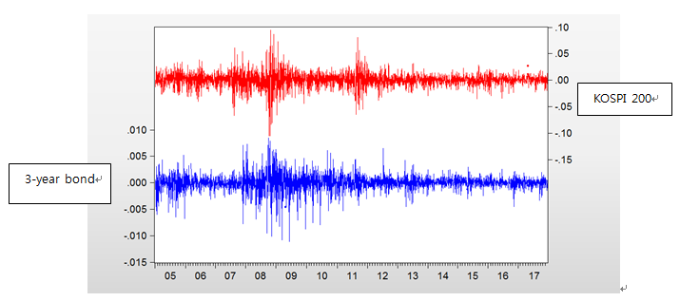

Panel (B) Inflation (DCPI) and Gross Domestic Product Growth (DGDP):
Inflation (DCPI) is calculated based on consumer price index (CPI). CPI is on a monthly basis, whereas GDP is on a quarterly basis. Intra-quarter GDP data are obtained by interpolation. All rates are in annual rates and in percent.
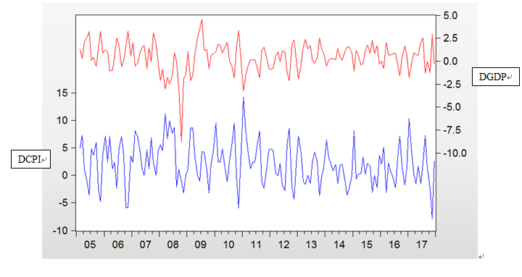

Panel (C) Business Leading Indicator (BL)
The number above (below) 100 anticipates positive (negative) outlook.
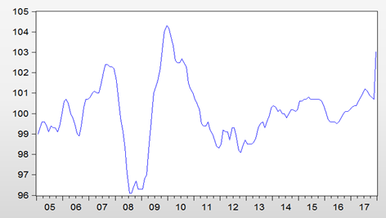

Panel (D) Money Supply Growth (MG)
Money supply growth is on a monthly basis, and measured by the log change of M1.
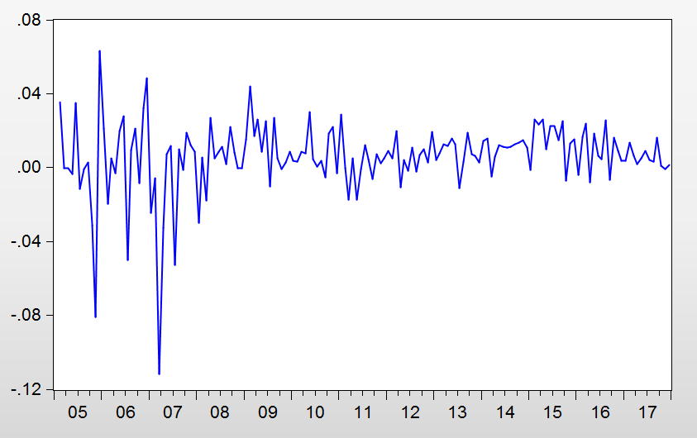

Panel (E) Market Implied Volatility (IV) and CDS Spread
IV is computed by using the daily closing prices of at-the-money call and put options. IV is measured in percent while CDS spread in basis point.
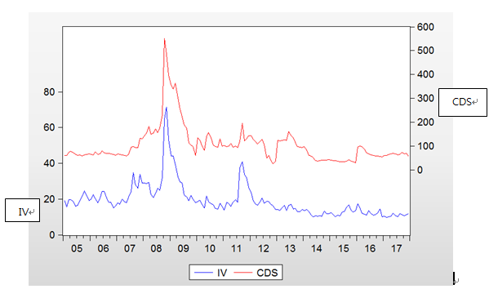
Figure 2. The Time Series of Stock Return and Yield Change
(1997-1999)
The log return of stock is calculated using the daily closing spot prices of stock index (KOSPI 200). The daily closing yields are on the 1-year monetary stabilization bond, and the 3-year corporate bond, respectively. The yield change is the difference in yield over one day, and expressed in percentage point.
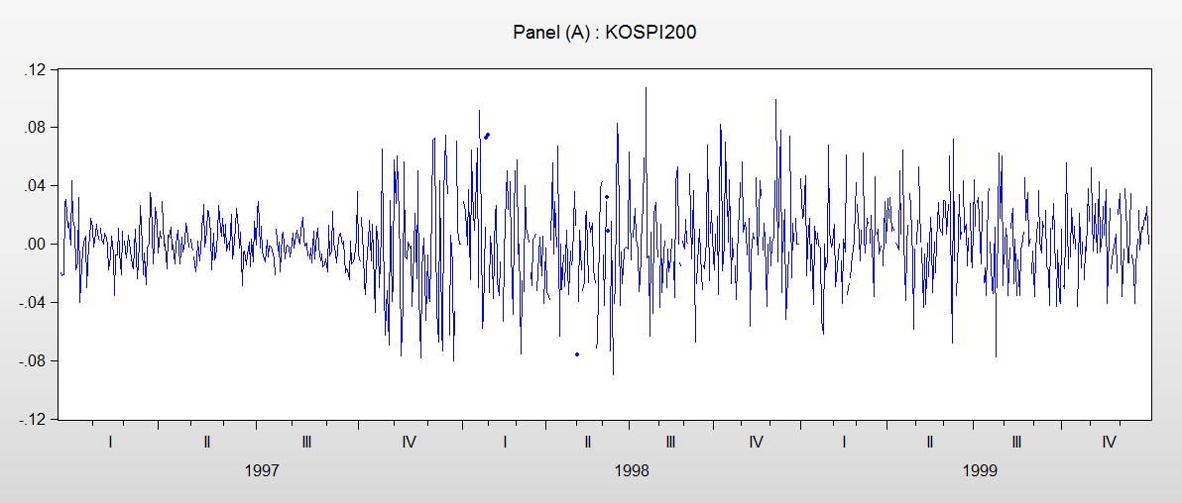

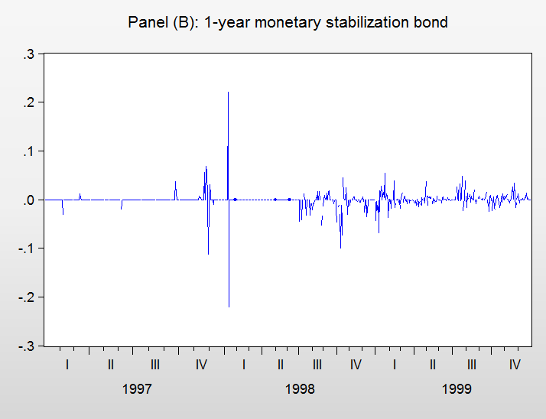
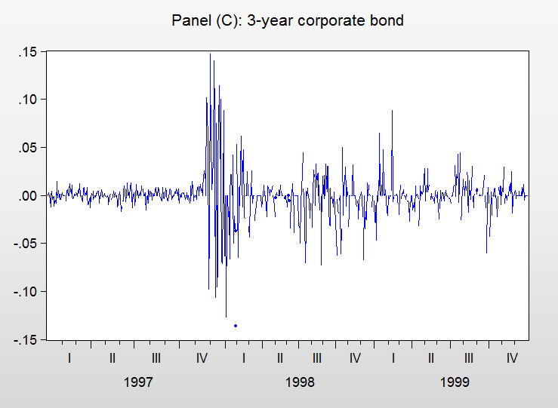

Figure 3. Stock and Bond Returns Correlation (2005-2017)
Stock and bond returns are calculated from the daily closing prices of stock index (KOSPI 200) futures and 3-year government bond futures. We estimate the stock-bond correlations using three methods, respectively; (1) 22-day RWC (Panel A), (2) MDCC(1,1) (Panel B), and (3) ADCC(1,1) (Panel C)
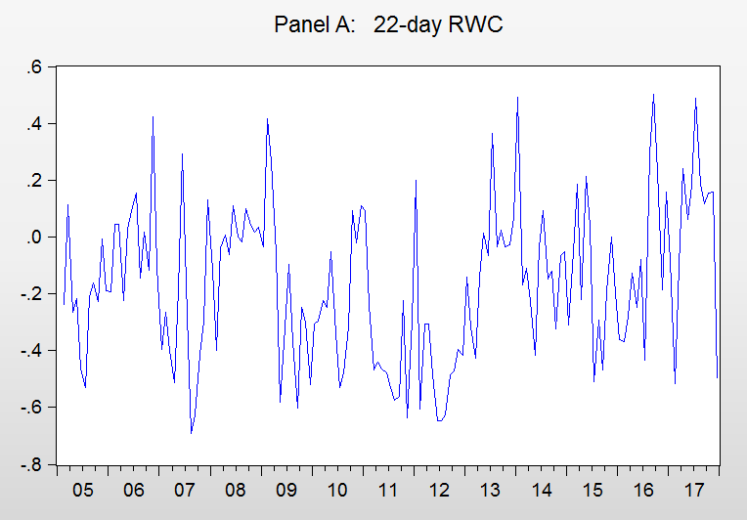

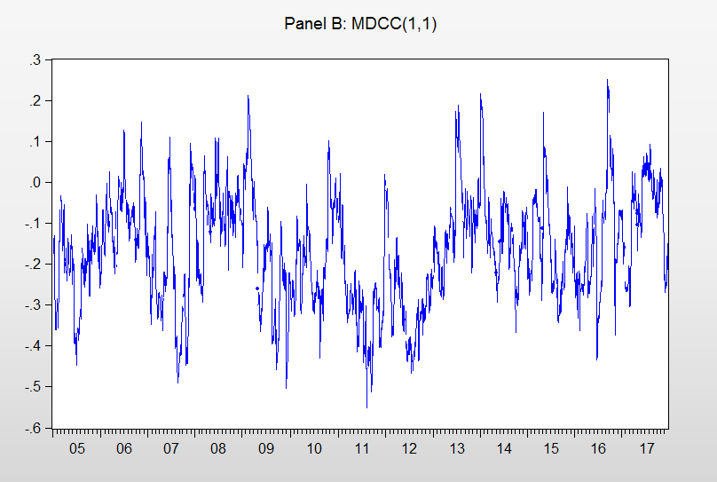

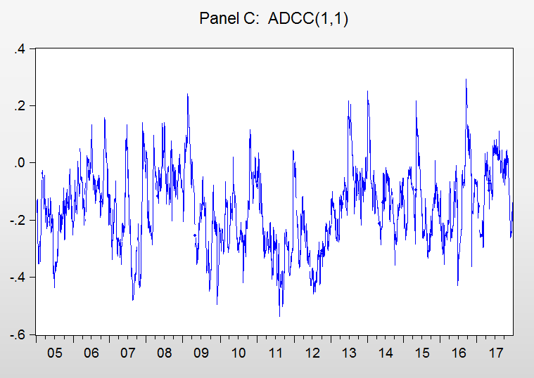

Figure 4. The Time Series of Stock Index and Bond Yield
(1997-1999)
The stock index is the daily closing KOSPI 200 spot index. The bond yield on 3-year corporate bond is expressed in percent per annum.
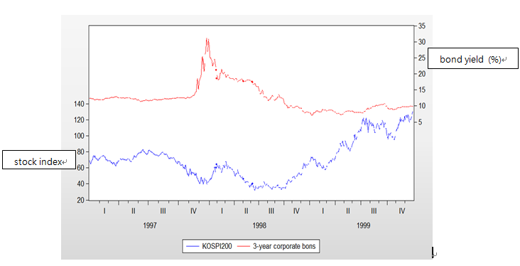
Figure 5. Stock Return and Bond Yield Change Correlation
(1997-1999)
The stock return is the daily log return of KOSPI 200 spot index. The bond yield changes are the differences in yields over one day of 1-year monetary stabilization bond and 3-year corporate bond, respectively. The correlations are estimated using the MDCC(1,1) model.
.

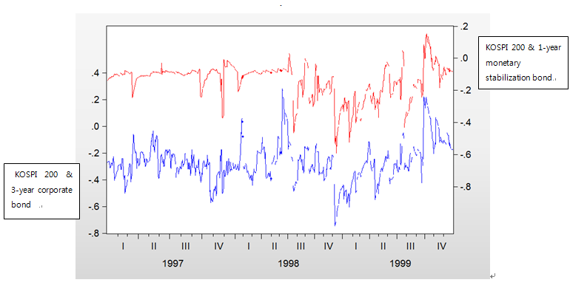

Footnote
1. The CDS spreads from 2005 to 2009, and from 2010 to 2017 are quoted from the contracts maturing in 2013, and in 2019, respectively. They are all at monthly frequency..

2. Merchant bank differs from commercial bank in that the former cannot take deposit from depositors, but the latter can. Merchant bank instead borrow issuing short-term paper and bond to institutional investors home and abroad.
3. For a good discussion of financial time series analysis, see Tsay (2010).

4. We do not report here the results of ARMA(1, 1), ARMA (2, 1) , and ARMA (2, 2) models, which are available upon request from the author.

5. We could not conduct a regression test of (5) spanning the time period of 1997-1999 because the data of CDS spread was not available.

6. The regression result of (5) using the RWC is very similar to that of (5) using the DCC(1,1), and we do not report it here.

Acknowledgement

We acknowledge that the research is funded by Korea Research Foundation (grant # A2017-0245).

